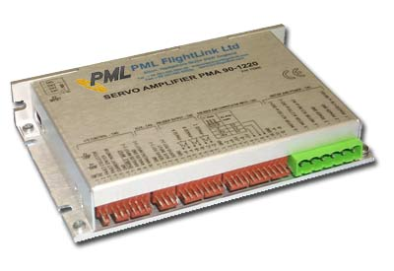

Features

- Motors supported:
- Brushless DC 60°/120° commutated
- Brushed DC
- Printed Armature DC

- 18 to 180VDC single power supply

- Up to 20A peak / 12A continuous current

- Selectable modes of operation:
- Current (Torque)
- Encoder Velocity
- Analogue position
- Tacho Velocity
- Hall Velocity

- Individually adjustable continuous and peak current limits

- Comprehensive short-circuit protection:
- Output to output
- Output to ground
- Output to power

- Over/under voltage shutdown

- Internal fast blowing fuse for maximum safety

- No integrator windup during power-up or if the amplifier is disabled

- Four quadrant regenerative operation

- Small footprint, low cost, easy to use

Description:

The PMA 90/180 servo amplifier is designed for applications using brushed DC motors, low inductance printed armature motors or brushless DC motors up to 750W.

It provides a full set of features for motor control including amplifier enable and direction enable inputs for connection to limit switches, and all necessary protections for the motor and amplifier. The PMA 90/180 can be used in conjunction with digital servo controllers or as a stand-alone drive.

Input gain, loop gain and offset can be adjusted. The offset potentiometer can also be used as an on-board full range reference signal.

A configurable component carrier and mode switches are used to select the operation mode and to customise the amplifier for specific motor parameters. Individually adjustable peak and continuous current limits allow high acceleration without sacrificing protection against continuous overloads. Peak current time can be adjusted from 50 ms to 3 sec.

TECHNICAL SPECIFICATIONS rated at 25ºC ambient, POWER (+)=60VDC, Load=250μH motor

DC POWER SUPPLY VOLTAGE
PMA 180-0406  PMA 90-0812  PMA 90-1220 |  | 18 to 180VDC (200VDC Abs. Max)  18 to 90VDC (100VDC Abs. Max)  18 to 90VDC (100VDC Abs. Max)
OUTPUT CURRENT
PMA 90-0406 continuous / peak  PMA 90-0812 continuous / peak  PMA 90-1220 continuous / peak |  | 4A / 6A  8A / 12A  12A / 20A
OPERATING MODES |  | Current (torque) - as delivered  Encoder Velocity  Analogue Position  Tacho Velocity  Hall Velocity
COOLING
Convection cooling  Forced air cooling or heatsink maintaining 60ºC max |  | Output continuous current less than:  ± 2A - PMA 180-0406  ± 4A - PMA 90-0812  ± 6A - PMA 90-1220  Current higher than listed above
OUTPUT VOLTAGE |  | Vout= 0.96(HV) – 0.21(Iout)
MINIMUM LOAD INDUCTANCE  Note: for use with printed armature motors it is recommended that an external inductance of at least 100μH (total) is added in series with the motor leads |  | 200μH
SMALL SIGNAL BANDWIDTH  Note: actual bandwidth will depend on power supply voltage, load inductance, and configurable components |  | 2.5KHz with 250μH load
PWM SWITCHING FREQUENCY |  | 40KHz
ANALOGUE INPUT CHARACTERISTICS |  | Differential, ±10V (±20V max), 50K to GND
GAINS – Current mode  PMA 180-0406  PMA 90-0812  PMA 90-1220 |  | 0.5 A/V as delivered. Adjustable 0 to 5 A/V  1 A/V as delivered. Adjustable 0 to 10 A/V  1.6 A/V as delivered. Adjustable 0 to 16 A/V
POTENTIOMETERS
INPUT GAIN  LOOP GAIN  OFFSET |  | Attenuates ANALOGUE INPUT from x 1 to zero  Increases A/V gain in current mode  Controls bandwidth in velocity mode  ORR = 10M – adjusts the imbalance in the input signal or in the servo amplifier  ORR = 220K – can be used as on board reference signal driving servo amplifier output up to ±100%
COMMUTATION |  | 60/120º hall mode
ENCODER AND COMMUTATOR INPUTS |  | HI: ≥ 1.5V, LO: ≤ 0.9V (–0.5VDC to + 5.5VDC Abs. Max)  Hysteresis TYP. = 0.6V, Pull up to +5V = 3K3
AUX INPUT |  | ±3V to ±50VDC (±60V Abs.Max)
LOGIC INPUTS | SW4=ON pull down resistors – 3K3 (accepts external voltage) |  | SW4=OFF pull up resistors – 3K3 (amplifier supplies 5V)
ENABLE INPUT  PE  NE | HI: 3.5V ≤ V ≤ 30V, LO: 0V ≤ V ≤ 1.2V  HI enables amplifier, LOW (OPEN) inhibits  HI enables positive d.o. rotation, LOW (OPEN) inhibits  HI enables negative d.o. rotation, LOW (OPEN) inhibits |  | HI: 3.5V ≤V ≤ 5V, LO: 0V ≤ V ≤ 1.2V  LO enables amplifier, HI (OPEN) inhibits  LO enables positive d.o. rotation, HI (OPEN) inhibits  LO enables negative d.o. rotation, HI (OPEN) inhibits
POWER UP DELAY |  | <1.5 sec
FAULT OUTPUT
Optocoupler  Umax=35V Imax=20mA |  | ON – when operates normally  OFF- when amplifier is disabled, motor output is shorted, temperature sensor is activated, or power supply is out of range
INDICATOR (LED) |  | GREEN when operating normally  RED when amplifier is disabled, output is shorted, temperature sensor is activated, or power supply is out of range
CURRENT MONITOR
10K, 10nF RC filter  PMA 180-0406  PMA 90-0812  PMA 90-1220 |  | ± 3.6V at ±6A (0.6V/A)  ± 3.6V at ±12A (0.3V/A)  ± 3.6V at ±20A (0.18V/A)
PROTECTION
Output short (output to output, output to ground, output to POWER (+))  Power supply voltage too low (undervoltage)  Power supply voltage too high (overvoltage)  Overtemperature |  | Shutdown when output is shorted with self resume  Shutdown at POWER (+) < 18VDC with self resume  Shutdown (with self resume) at:  POWER (+) > 91VDC for PMA 90-812, PMA 90-1220  POWER (+) > 180VDC for PMA 90-46  Shutdown at 75 °C internal temperature with self resume
FIRE SAFETY – internal fuse |  | 10A Quick blow
POWER DISSIPATION
Minimum power consumption at 0A output, 18VDC power supply  Power dissipation at 5A output, 60VDC power supply  Power dissipation at 10A output, 60VDC power supply |  | 2W  16W  32W
THERMAL REQUIREMENTS
Storage temperature range  Operating temperature range |  | –30 to +85 °C  0 to 45 °C
MECHANICAL
Size  Weight |  | 5.5 x 3.5 x 1 in. (140 x 89 x 25.4 mm)  0.65 lb. (0.3 kg)

MATING CONNECTORS | RECOMMENDED CONNECTOR TYPE
MOTOR AND POWER  ENCODER AND COMUTATOR INPUT  ENCODER OUTPUT  AUX  I/O CONTROL | Magnum EM2565-06-VL or Phoenix: MSTB 2.5/6-ST-5.08  Molex: 22-01-3127 housing with 08-50-0114 pins (12pcs)  Molex: 22-01-3077 housing with 08-50-0114 pins (7pcs)  Molex: 22-01-3047 housing with 08-50-0114 pins (4pcs)  Molex: 22-01-3107 housing with 08-50-0114 pins (10pcs)

OUTLINE DIMENSIONS in millimetres

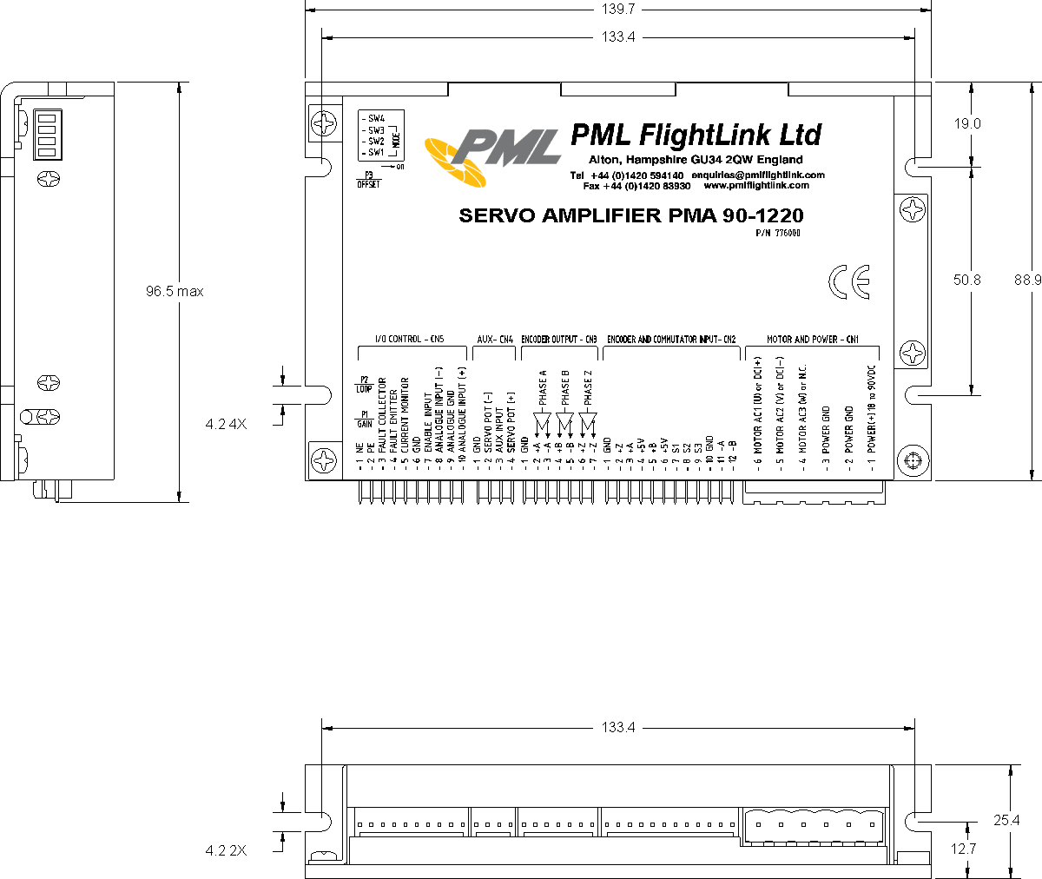

AMPLIFIER LAYOUT

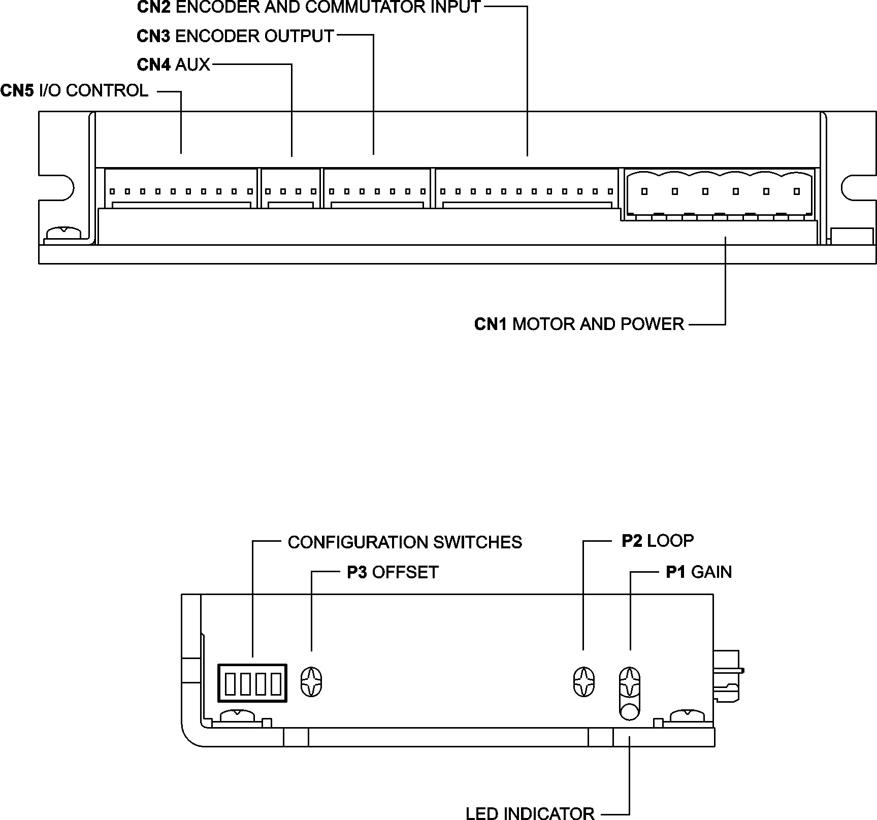

ORDERING GUIDE
PART NUMBER | MODEL | DESCRIPTION
776005 | PMA 180-0406 | AC/DC Servo Amplifier 6A/180V
776006 | PMA 90-0812 | AC/DC Servo Amplifier 12A/90V
776000 | PMA 90-1220 | AC/DC Servo Amplifier 20A/90V
776004 | PMA 90 CN | Mating connector kit
CONNECTORS AND PINOUTS

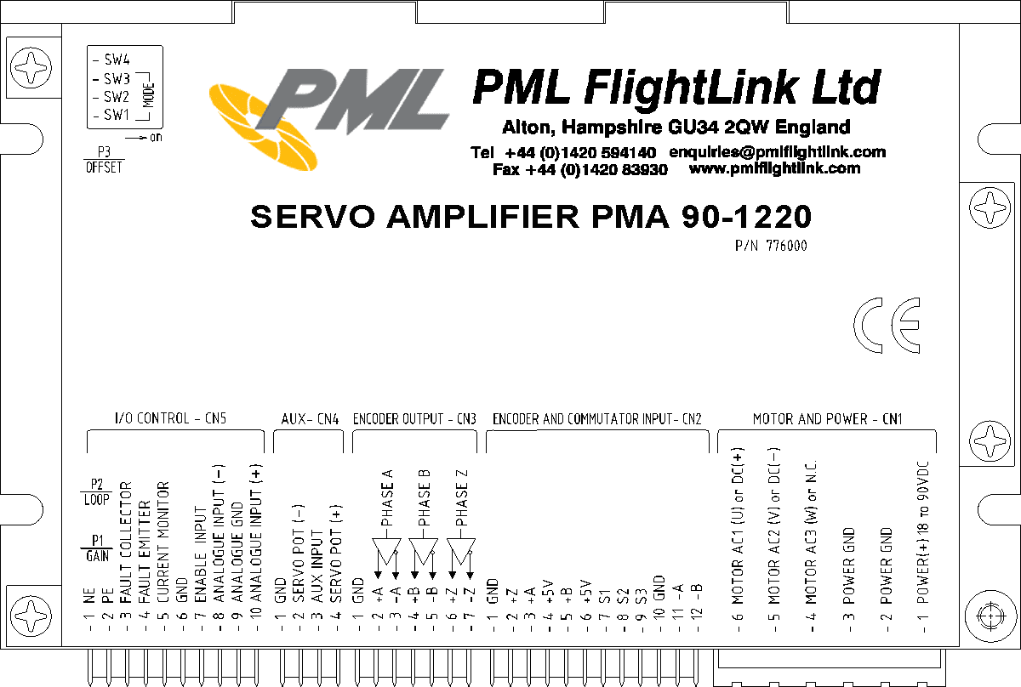

CN1 – MOTOR AND POWER
PIN | SIGNAL | DESCRIPTION
1 | POWER +18 to +90VDC | DC Power Supply Input  PMA 90-0812, PMA 90-1220 - 18 to 90VDC  PMA 180-0406 - 18 to 180VDC
2 and 3 | POWER GND* | Power Supply Return and Amplifier GROUND
4 | MOTOR AC3 (W) or NC | Amplifier Output to Motor phase 3 for brushless motors  Not connected for brushed motors
5 | MOTOR AC2 (V) or DC(-) | Amplifier Output to Motor phase 2 for brushless motors  Amplifier Output to Motor (-) terminal for brushed motors
6 | MOTOR AC1 (U) or DC(+) | Amplifier Output to Motor phase 1 for brushless motors  Amplifier Output to Motor (+) terminal for brushed motors

CN2 – ENCODER AND COMMUTATOR INPUT
PIN | SIGNAL | DESCRIPTION
1 | GND* | Encoder ground
2 | +Z | Encoder Index positive terminal
3 | +A | Encoder phase A positive terminal
4 | +5V | Encoder power supply
5 | +B | Encoder phase B positive terminal
6 | +5V | Commutator power supply
7 | S1 | Hall sensor input 1 for brushless motors, NC for brushed motors
8 | S2 | Hall sensor input 2 for brushless motors, NC for brushed motors
9 | S3 | Hall sensor input 3 for brushless motors, NC for brushed motors
10 | GND* | Commutator ground
11 | -A | Encoder phase A negative terminal
12 | -B | Encoder phase B negative terminal
*Note: POWER GND, GND and ANALOGUE GND are electrically connected. Amplifier case is isolated from
the amplifier circuitry and can be grounded externally.

CN3 – ENCODER OUTPUT
PIN | SIGNAL | DESCRIPTION
1 | GND* | Signal ground
2 | +A | Phase A output positive terminal
3 | -A | Phase A output negative terminal
4 | +B | Phase B output positive terminal
5 | -B | Phase B output negative terminal
6 | +Z | Index output positive terminal
7 | -Z | Index output negative terminal

CN4 – AUX
PIN | SIGNAL | DESCRIPTION
1 | GND* | Signal ground
2 | SERVO POT (-) | -5V Reference voltage output with 1K5 resistor in series
3 | AUX INPUT | Tachometer input  Potentiometer input in analogue position mode
4 | SERVO POT (+) | +5V Reference voltage output with 1K5 resistor in series

CN5 – I/O CONTROL
PIN | SIGNAL | DESCRIPTION
1 | NE | SW4=ON | SW4=OFF
1 | NE | HI (3.5V ≤ V ≤ 30V) if the direction is enabled  LO (0V ≤ V ≤ 1.2V or OPEN) if the direction is disabled | LO (0V ≤ V ≤ 1.2V) if the direction is enabled  HI (3.5V ≤ V ≤ 30V or OPEN) if the direction is disabled
2 | PE | SW4=ON | SW4=OFF
2 | PE | HI (3.5V ≤ V ≤ 30V) if the direction is enabled  LO (0V ≤ V ≤ 1.2V or OPEN) if the direction is disabled | LO (0V ≤ V ≤ 1.2V) if the direction is enabled  HI (3.5V ≤ V ≤ 30V or OPEN) if the direction is disabled
3 | FAULT COLLECTOR | Optocoupler  Fault = OFF (open)
4 | FAULT EMITTER
5 | CURRENT MONITOR | Current monitor output  PMA 180-0406 - ± 0.6 V/A  PMA 90-0812 - ± 0.3 V/A  PMA 90-1220 - ± 0.18 V/A
6 | GND* | Signal ground
7 | ENABLE INPUT | SW4=ON | SW4=OFF
7 | ENABLE INPUT | Amplifier enable input  HI (3.5V ≤ V ≤ 30V) enables the amplifier  LO (0V ≤ V ≤ 1.2V or OPEN) disables the amplifier | Amplifier enable input  LO (0V ≤ V ≤ 1.2V) enables the amplifier  HI (3.5V ≤ V ≤ 30V or OPEN) disables the amplifier
8 | ANALOGUE INPUT (–) | Negative analogue input ±10V
9 | ANALOGUE GND* | Analogue ground
10 | ANALOGUE INPUT (+) | Positive analogue input ±10V
*Note: POWER GND, GND and ANALOGUE GND are electrically connected. Amplifier case is isolated from the amplifier circuitry and can be grounded externally.

MODE SELECT DIP SWITCHES
SW1 | SW2 | SW3 | Encoder | MODE SELECT TABLE
OFF | ON | ON | X | Brushed or Brushless motors - any mode other than Hall and Encoder Velocity
SYNC* | OFF | ON | X | Brushless motors - Hall Velocity mode  NOTE: SYNC should be ON or OFF depending on motor winding / hall sensor phasing.
ON | ON | OFF | 2500
ON | ON | OFF | 2000/2048
ON | ON | OFF | 1500/1536
OFF | ON | OFF | 1000/1024 | Brushed or Brushless motors - Encoder Velocity mode
OFF | ON | OFF | 750/768
ON | OFF | OFF | 500/512
OFF | OFF | OFF | 250/258
OFF | OFF | OFF | 100/128
*NOTE: SYNC should be ON or OFF depending on motor winding / hall sensor phasing.

ENABLE, PE and NE polarity DIP SW4
SW4 | ENABLE, PE and NE
ON | Active HIGH (for sensors with sourcing output)
OFF | Active LOW (for sensors with open collector output)

POTENTIOMETER FUNCTIONS
POT. | FUNCTION | DESCRIPTION
P1 | INPUT GAIN | Adjusts the ratio between the analogue input signal and servo amplifier output
P2 | LOOP GAIN | Adjusts voltage to current transfer ratio in current mode  Adjusts loop gain and bandwidth in velocity, open loop and analogue position modes
P3 | OFFSET | ORR = 10M – compensates the input signal imbalance and servo amplifier offset (low range)  ORR = 220K –on board reference signal source driving amplifier output up to ±100%
FUNCTIONAL DIAGRAM

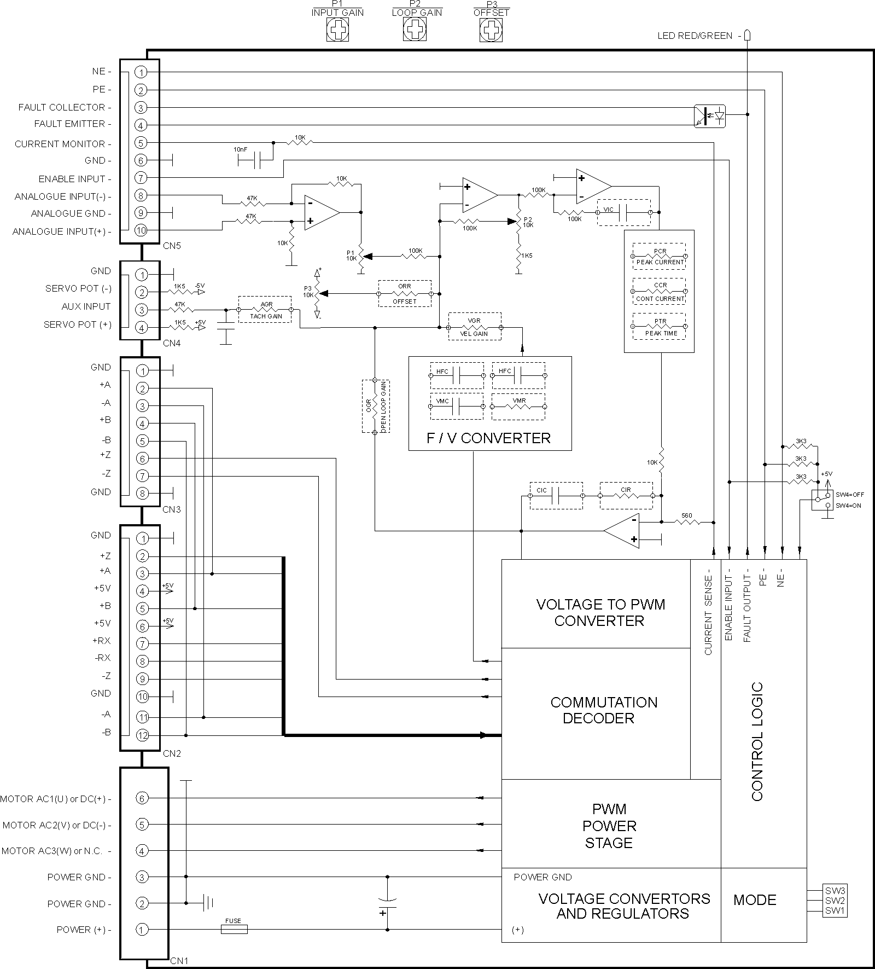
MODE SELECT TABLES
Set the mode switches according to the table:
MOTOR TYPE – MODE | Encoder | SW1 | SW2 | SW3
Brushed or Brushless motors - any mode other than Hall and Encoder Velocity | X | OFF | ON | ON
Brushless motors - Hall Velocity mode | X | SYNC* | OFF | ON
 | 2500 | ON | ON | OFF
 | 2000/2048 | ON | ON | OFF
 | 1500/1536 | ON | ON | OFF
Brushed or Brushless motors - Encoder Velocity mode | 1000/1024 | OFF | ON | OFF
 | 750/768 | OFF | ON | OFF
 | 500/512 | ON | OFF | OFF
 | 250/258 | OFF | OFF | OFF
 | 100/128 | OFF | OFF | OFF
*NOTE: SYNC should be ON or OFF depending on motor winding / hall sensor phasing.

Select enable inputs active level:
SW4 | ENABLE, PE and NE
ON | Active HIGH (for sensors with sourcing output)
OFF | Active LOW (for sensors with open collector output)

Install the appropriate components on Configurable Component Carrier according to the table:
MODE | PCR | CCR | CIR | CIC | VIC | PTR | OGR | ORR | AGR | VGR | VMR | VMC | HFC
Torque | R | R | R | C | SHORT | R | OPEN | R | OPEN | OPEN | 100K | OPEN | OPEN
Encoder velocity | R | R | R | C | C | R | OPEN | R | OPEN | R | 100K | 1nF | OPEN
Hall velocity | R | R | R | C | C | R | OPEN | R | OPEN | R | R | 10nF | 2x  10nF
Open loop | R | R | R | C | C | R | R | R | OPEN | OPEN | 100K | OPEN | OPEN
Tacho velocity | R | R | R | C | C | R | OPEN | R | R | OPEN | 100K | OPEN | OPEN
Analogue position | R | R | R | C | C | R | Typically 1M | R | Typically  47K | OPEN | 100K | OPEN | OPEN

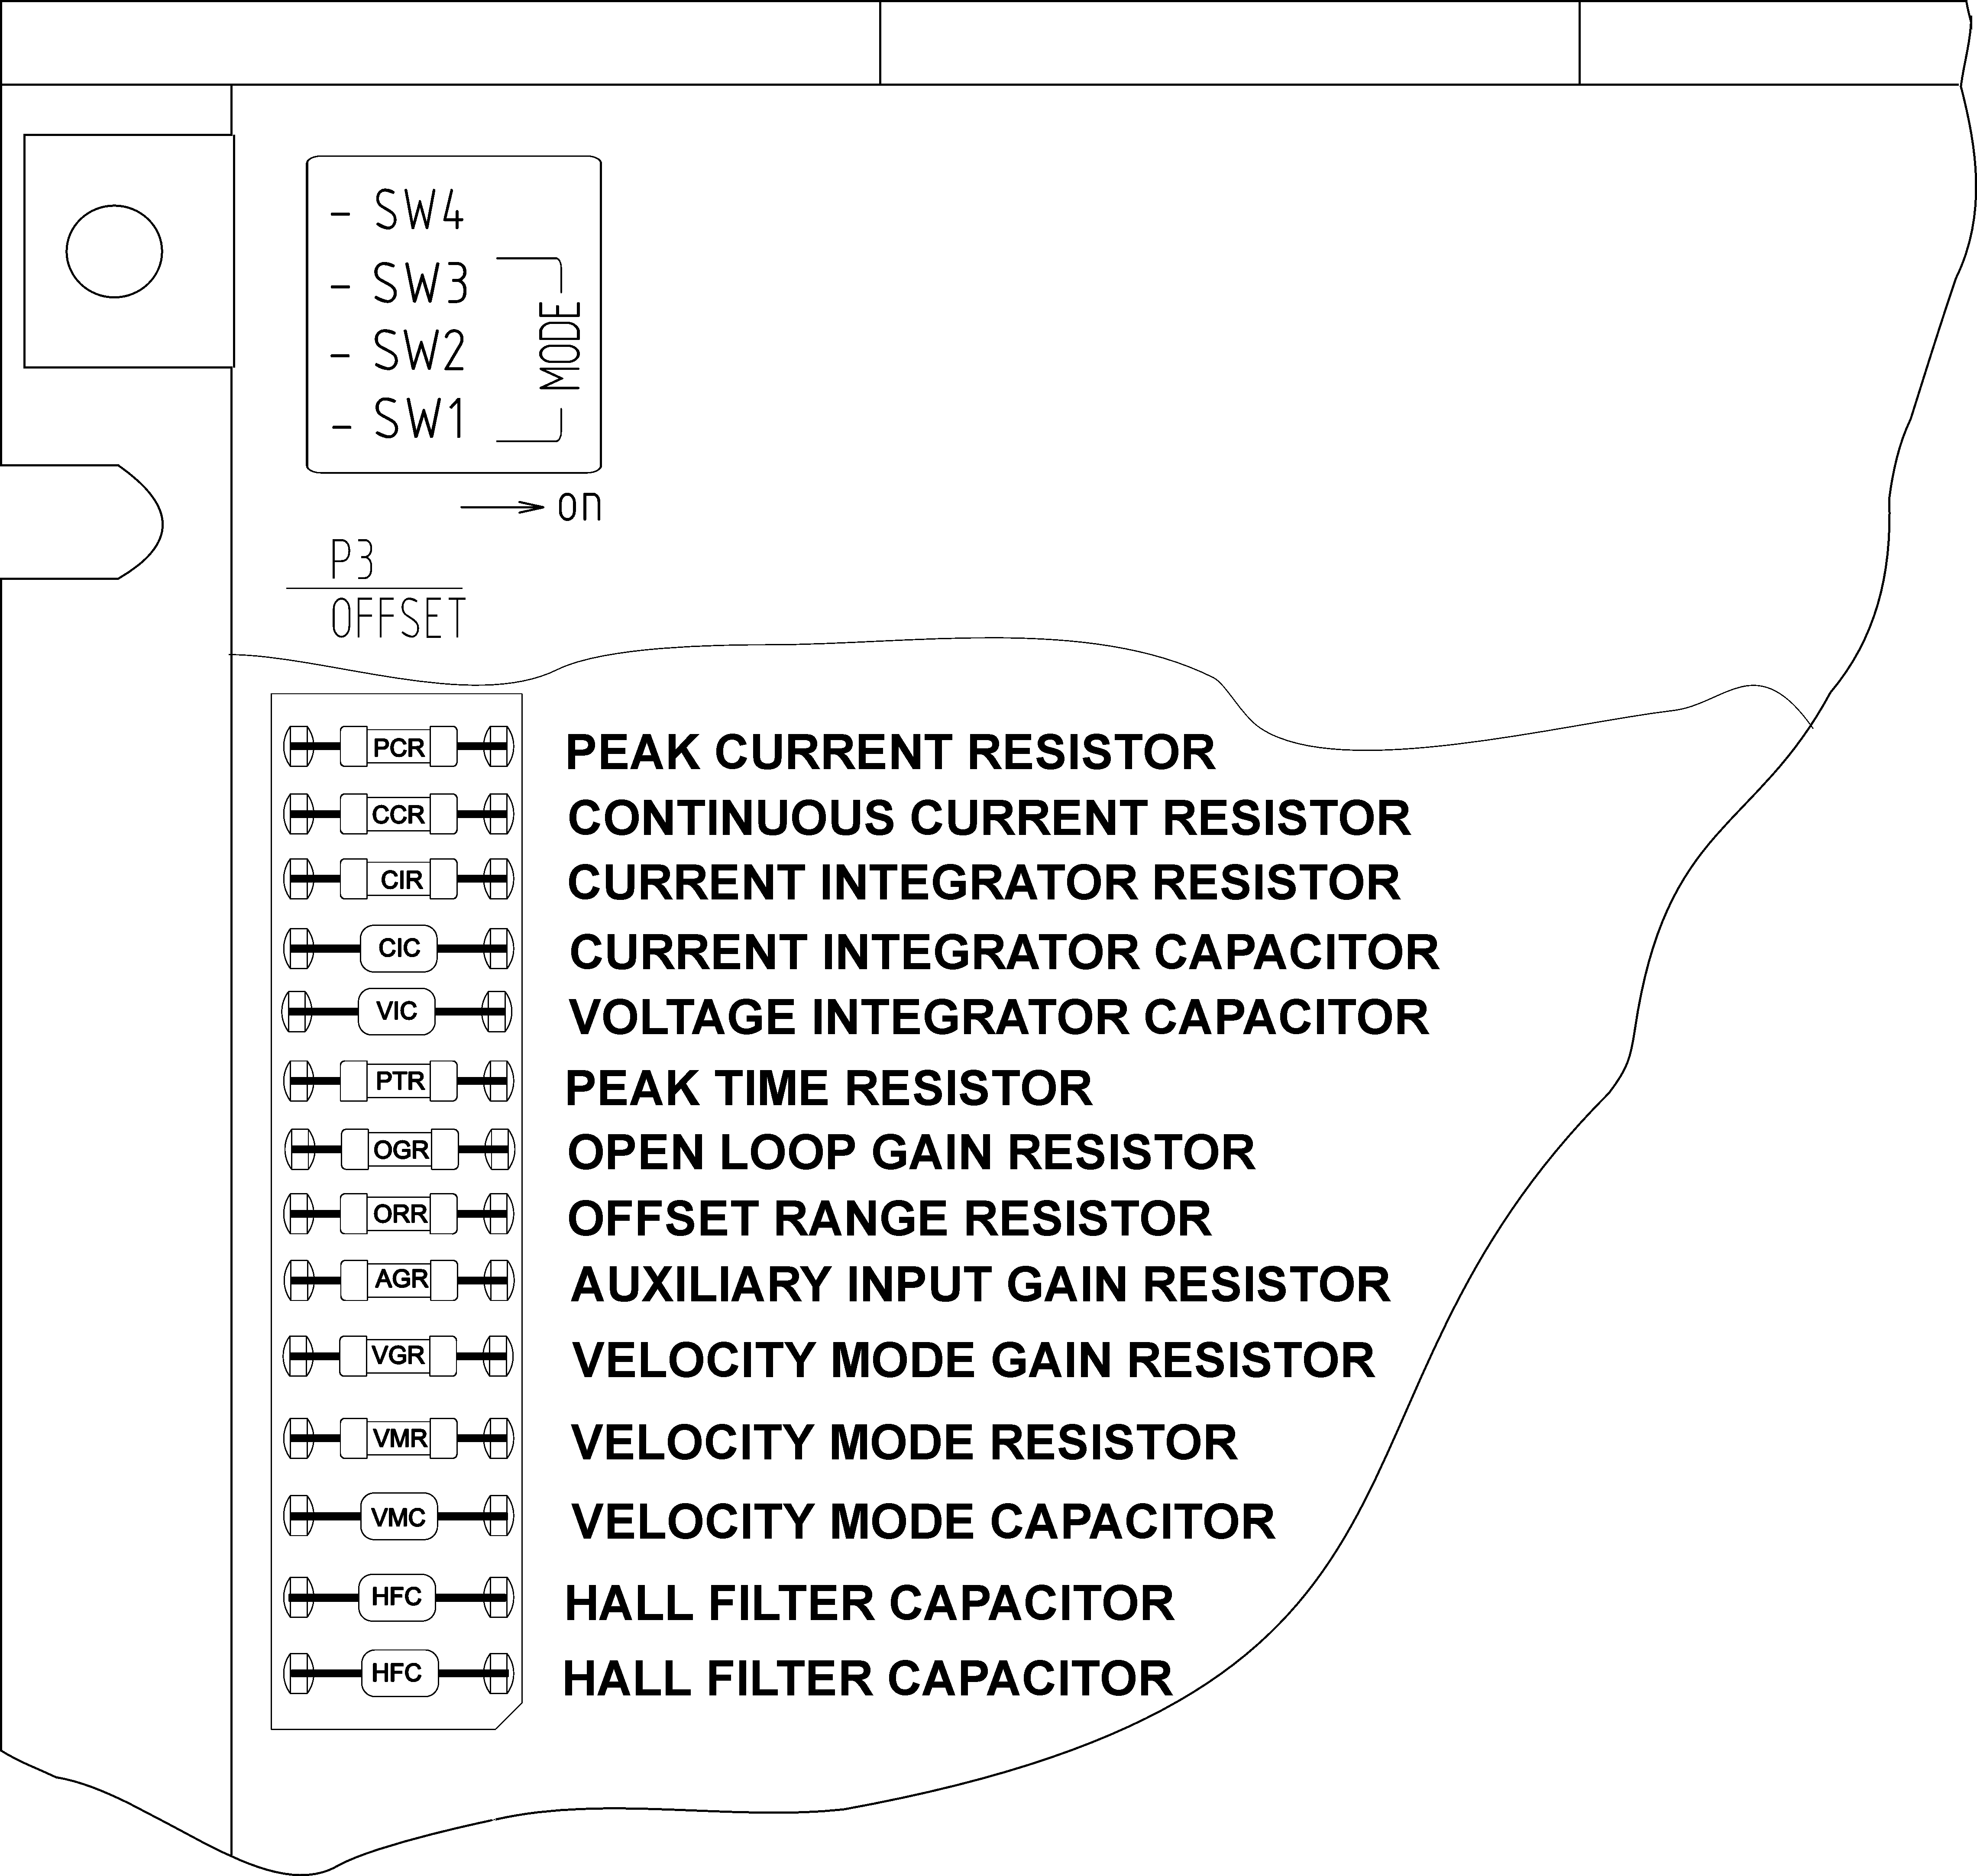

CONFIGURABLE COMPONENTS SETTING

PCR is the adjusting resistor for peak current limit (factory standard setting - PCR=SHORT).
CCR is the adjusting resistor for continuous current limit (factory standard setting - CCR=SHORT).
The table below shows component values for the most used continuous and peak current combinations.

I peak (A)  PMA 90/180  0406 / 0812 / 1220 | I cont (A)  PMA 90/180  0406 / 0812 / 1220 | PCR | CCR |  | I peak (A)  PMA 90/180  0406 / 0812 / 1220 | I cont (A)  PMA 90/180  0406 / 0812 / 1220 | PCR | CCR
6 / 12 / 20 | 4 / 8 / 13 | SHORT | SHORT |  | 3 / 6 / 10 | 1.7 / 3 / 5 | 27K | 36K
6 / 12 / 20 | 3 / 6 / 10 | SHORT | 10K |  | 2.5 / 5 / 8.3 | 1.2 / 2.5 / 4.2 | 36K | 47K
5 / 10 / 17 | 3 / 6 / 10 | 5k6 | 5K6 |  | 2 / 4 / 7 | 1 / 2 / 3.3 | 56K | 75K
5 / 10 / 17 | 2.5 / 5/ 8 | 5K6 | 16K |  | 1.7 / 3 / 5 | 0.7 / 1.5 / 2.5 | 82K | 110K
4 / 8 / 13 | 2 / 4 / 7 | 15K | 24K |  | 1 / 2 / 3.3 | 0.5 / 1 / 1.7 | 130K | 150K
3.5 / 7 / 12 | 1.8 / 3.5 / 6 | 20K | 30K |  | 0.5 / 1 / 1.7 | 0.2 / 0.5 / 0.8 | 220K | 330K

CIR is the current integrator resistor (factory standard setting - CIR=22K).
CIC is the current integrator capacitor (factory standard setting - CIC=100nF).
The values of these components are related to the amplifier bandwidth and have to be configured depending on the motor inductance and power supply voltage.
Optimisation procedure
Set the amplifier in current mode by putting jumper wire instead of VIC. Set P1 and P2 fully CCW. Connect the motor and power supply to the amplifier. Apply a square wave signal ±1V at 20 to 50Hz to amplifier ANALOGUE INPUT. Use an oscilloscope to measure the signal at current monitor (CN5-pin4). Enable the amplifier AMP ENABLE=LOW. Rotate P1 CW to set ±150mV square wave signal at the oscilloscope screen. Using CIR selected from the table below, select lowest value of CIC that does best result in overshoot or degradation of the pulse response.
The table below shows some approximate values of the current integrator resistor and capacitor depending on motor inductance.

LOAD INDUCTANCE | CIC | CIR
0.2 to 0.6mH | 47nF | 10K
0.7 to 1.9mH | 100nF | 10K
2.0 to 6.0mH | 100nF | 22K
7.0 to 20mH | 220nF | 22K
Note: Values in the table are for 24VDC power supply voltage. For higher voltages CIR should be decreased and CIC increased.

VIC is the voltage integrator capacitor (factory standard setting - VIC=SHORT).
For current mode the wire jumper or 0 Ohm resistor should be left in place. Changing of the wire jumper with a capacitor is necessary for all velocity, open loop and analogue position modes.
Proceed with CIR and CIC optimisation before VIC optimisation.
Optimisation procedure for TACHO VELOCITY mode
Set the amplifier in velocity mode putting VIC = 220nF. Set P1 fully CCW. Connect motor and tachometer. Power and enable the amplifier. Rotate the motor shaft manually. If the tachometer polarity is wrong, the motor will ”Run away”. If this happens, reverse tachometer wires (+) and (-). With correct tachometer polarity, the motor will resist the manual rotation of its shaft. Apply square wave signal ± 1V at 5 to 20 Hz to amplifier ANALOGUE INPUT. Move the oscilloscope probe to AUX INPUT pin. Rotate P1 CW to set ± 1V square wave signal at the oscilloscope screen. Find the best response (lowest rise time with minimum overshoots) by changing VIC and adjusting P2 LOOP GAIN.
Optimisation procedure for ENCODER VELOCITY mode
Set the amplifier in velocity mode putting VIC = 220nF. Set P1 fully CCW. Connect motor and encoder. Power and enable the amplifier. Rotate motors shaft slightly. If the encoder polarity is wrong the motor will ”Run away”. If this happens, swap encoder wires +A/+B and -A/-B. With correct encoder polarity, the motor will resist the manual rotation of its shaft. Apply square wave signal ± 1V at 5 to 20 Hz* to amplifier ANALOGUE INPUT. Move the oscilloscope probe to the control point shown on the picture below:

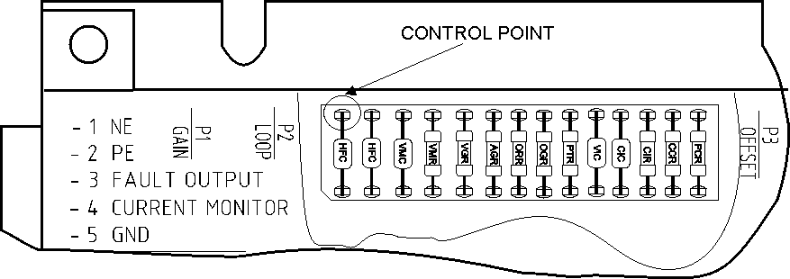

Rotate P1 CW to set ±250mV square wave signal at the oscilloscope screen. Find the best response (lowest rise time with minimum overshoots) by changing VIC and adjusting P2 LOOP GAIN.
Note: * For max speed 5000 rpm. For max speed 2500 rpm apply ±2V at 5 to 20Hz.

PTR is adjusting resistor for the peak time (factory standard setting - PTR=OPEN).
The table below shows some basic settings.

PEAK TIME | PTR |  | PEAK TIME | PTR
3 sec | OPEN |  | 0.5 sec | 68K
2 sec | 510K |  | 0.25 sec | 33K
1.5 sec | 330K |  | 0.1 sec | 15K
1 sec | 150K |  | 0.05 sec | SHORT

OGR is open loop gain resistor (factory standard setting - OGR=OPEN).
OGR converts the amplifier into a Voltage to PWM converter (OPEN LOOP mode).
To setup the OGR value use the table:

INPUT VOLTAGE | OGR | PWM
±10V | 68K | 100%
±5V | 130K | 100%

ORR is the offset range resistor (factory standard setting - ORR=10M).
Its value changes the range of regulation with the OFFSET potentiometer. For 100% regulation set the ORR = 220K. To reduce the regulation range, increase the resistor. Factory setting ORR = 10M gives enough range for input imbalance adjustment. Any values greater then 220K can be used.

AGR is an adjustment resistor affecting the amplifier in TACHO VELOCITY and ANALOGUE POSITION modes (factory standard setting - AGR=OPEN).
The resistor value changes amplifier auxiliary input sensitivity between ZERO (AGR=OPEN) and MAX (AGR=47K*). Choose the value of AGR depending on your application, between 47K and 2M2 (corresponding to ±2V and ±50V input sensitivity).
*Note: Do not use resistor with lower value than 47K.

VGR is the ENCODER VELOCITY and HALL VELOCITY mode gain resistor (factory standard setting - VGR=OPEN).
To select the VGR value use the following table:

 |  |  |  |  | VGR / max RPM
MODE | ENCODER | SW1 | SW2 | SW3 | 5Krpm | 2.5Krpm | 1.5Krpm
Hall Velocity | X | SYNC* | OFF | ON | 150K | 75K | 47K
 | 2500 | ON | ON | OFF | 150K | 75K | 47K
 | 2000/2048 | ON | ON | OFF | 120K | 60K | 36K
 | 1500/1536 | ON | ON | OFF | 91K | 47K | 27K
Encoder Velocity | 1000/1024 | OFF | ON | OFF | 150K | 75K | 47K
 | 750/768 | OFF | ON | OFF | 110K | 56K | 33K
 | 500/512 | ON | OFF | OFF | 150K | 75K | 47K
 | 250/256 | OFF | OFF | OFF | 150K | 75K | 47K
 | 100/128 | OFF | OFF | OFF | 56K | 27K | 16K
*NOTE: SYNC should be ON or OFF depending on motor winding / hall sensor phasing.

VMR is VELOCITY mode resistor (factory standard setting - VMR=100K).
To set the VMR use the following table:

MODE | COMMUTATIONS  PER REVOLUTION | VMR
 | 1 | 91K
Hall Velocity | 2 | 47K
 | 4 | 24K
 | 8 | 11K
Encoder Velocity | X | 100K
All other modes | X | 100K

VMC is VELOCITY mode capacitor (factory standard setting - VMC=OPEN).
To set the VMC use the following table:

MODE | VMC
Hall Velocity | 10nF
Encoder Velocity | 1nF
All other modes | OPEN

HFC are two 10nF capacitors used only in HALL VELOCITY mode (factory standard setting - HFC=OPEN).

MODE | HFC
Hall Velocity | 2x10nF
Encoder Velocity | OPEN
All other modes | OPEN

PHASING A BRUSHLESS MOTOR

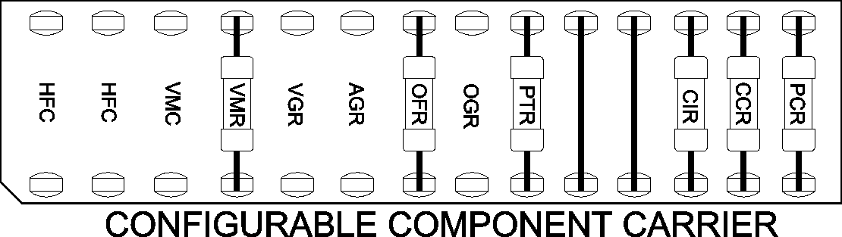
CN2 Signal | Motor manufacturer signal names
S1 | R | U | A | S1
S2 | S | V | B | S2
S3 | T | W | C | S3
Phasing procedure
Replace configurable components CIC and VIC with wire jumpers (SHORT). Replace OFR with resistor 3.0M. Connect the motor commutation sensors to CN2 using the table with the most popular manufacturers signal names. Connect the commutator power leads (+5V, GND).
Connect the three motor leads to AC1, AC2, and AC3 to CN1 using the same order as commutation sensor signals. Power and enable the amplifier. Rotate amplifier OFFSET potentiometer CW and CCW. If the motor is phased properly it will rotate smoothly in both directions. If the motor runs slower in one direction, needs help to start, or vibrates the phasing is incorrect. There are five more ways to connect the three motor wires. The best way is to try all the six combinations to find the right one, which should be quite obvious. If the motor is phased properly, the direction can be reversed interchanging S1/S3 and AC1/AC2.

LOGIC INPUTS AND FAULT OUTPUT

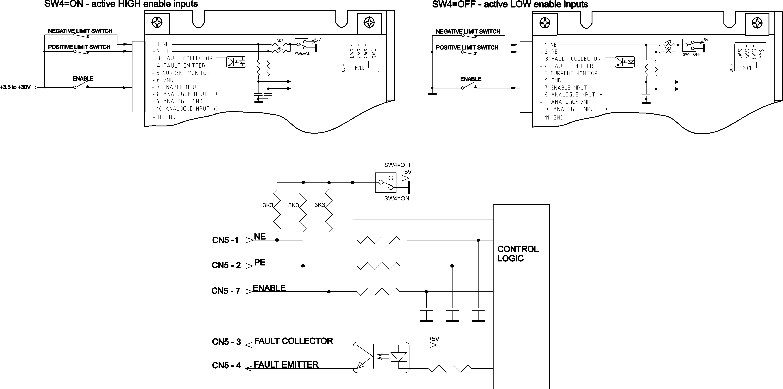
TYPICAL CURRENT (TORQUE) MODE APPLICATION FOR BRUSHLESS MOTORS
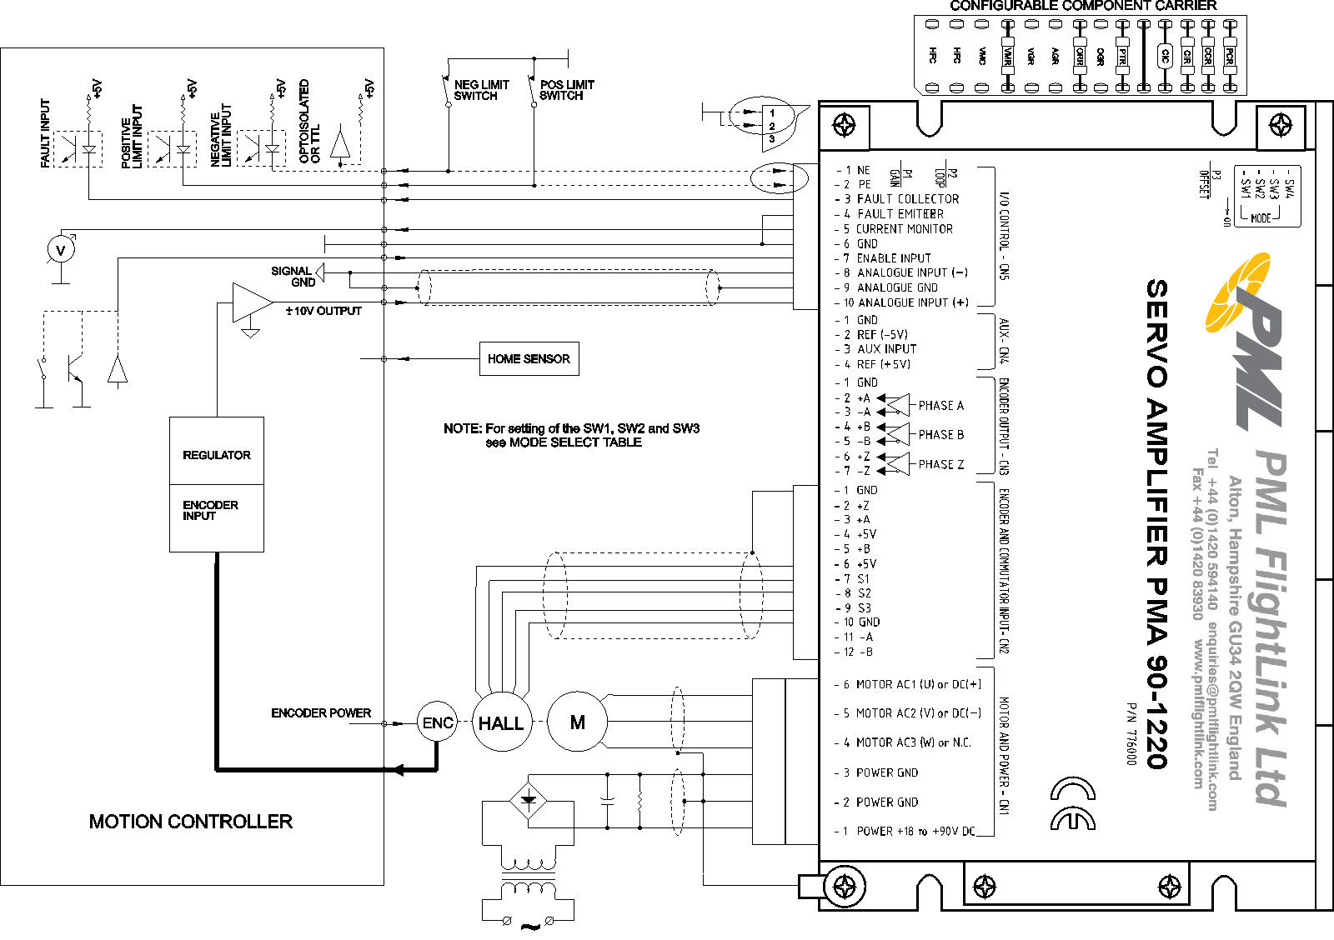

TYPICAL CURRENT (TORQUE) MODE APPLICATION FOR BRUSHED MOTORS
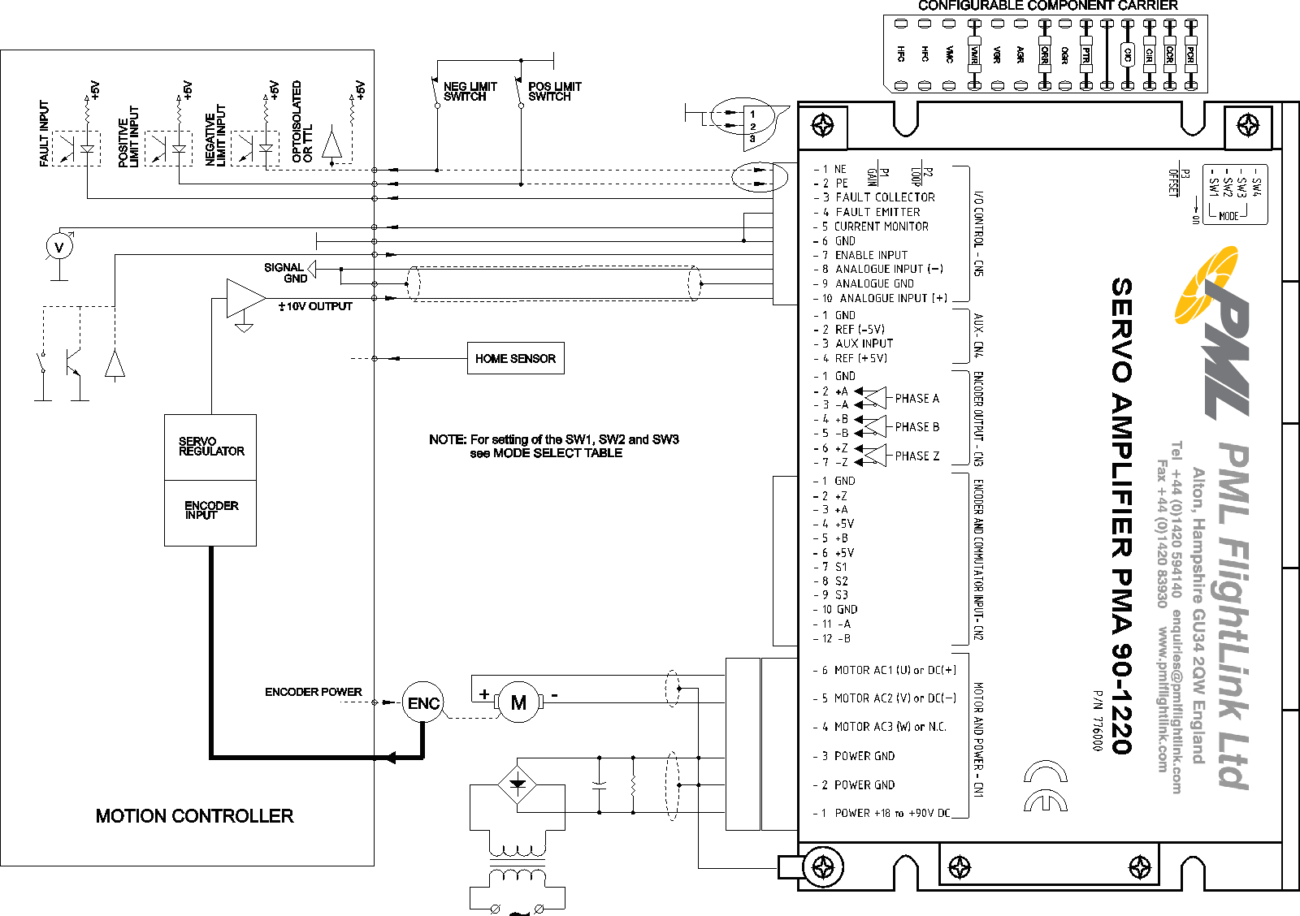
In CURRENT (TORQUE) mode the amplifier produces motor current proportional to the voltage applied to the ANALOGUE INPUT. Motor shaft torque is proportional to the motor current. Current mode gives best results (motor stiffness) if the servo amplifier is used with a digital position controller. P1 INPUT GAIN and P2 LOOP GAIN adjust the ratio between the input signal and amplifier output current. Set P1 INPUT GAIN to 50% and P2 LOOP GAIN fully CCW. To increase the gain turn P2 CW. To decrease the gain turn P1 CCW. In this mode, only CIC and CIR must be optimised.
CAUTION! Without controller this mode can produce motor “RUN AWAY”.

TYPICAL ENCODER VELOCITY MODE APPLICATION FOR BRUSHLESS MOTORS

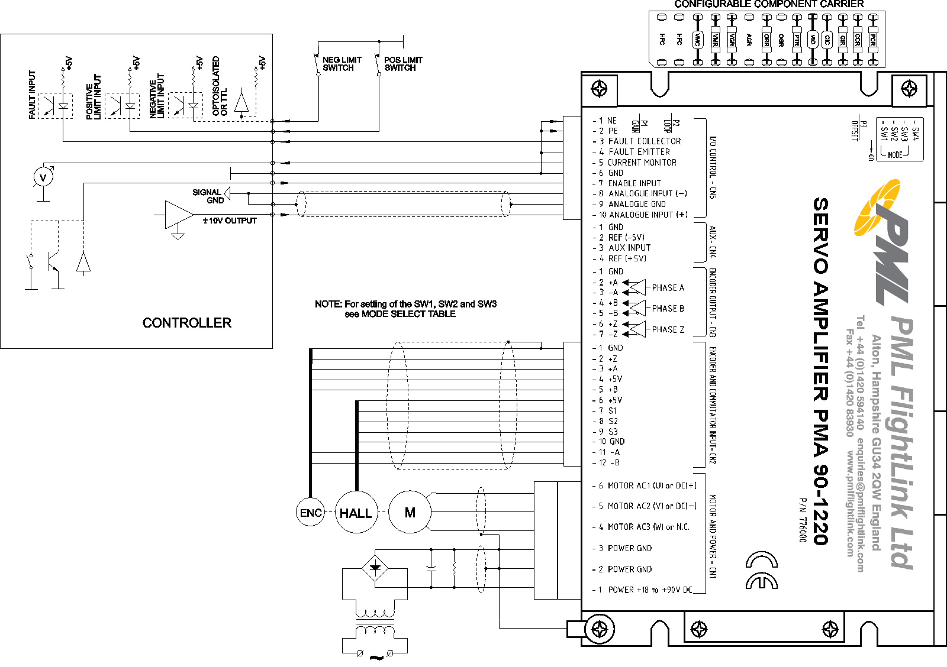

TYPICAL ENCODER VELOCITY MODE APPLICATION FOR BRUSHED MOTORS

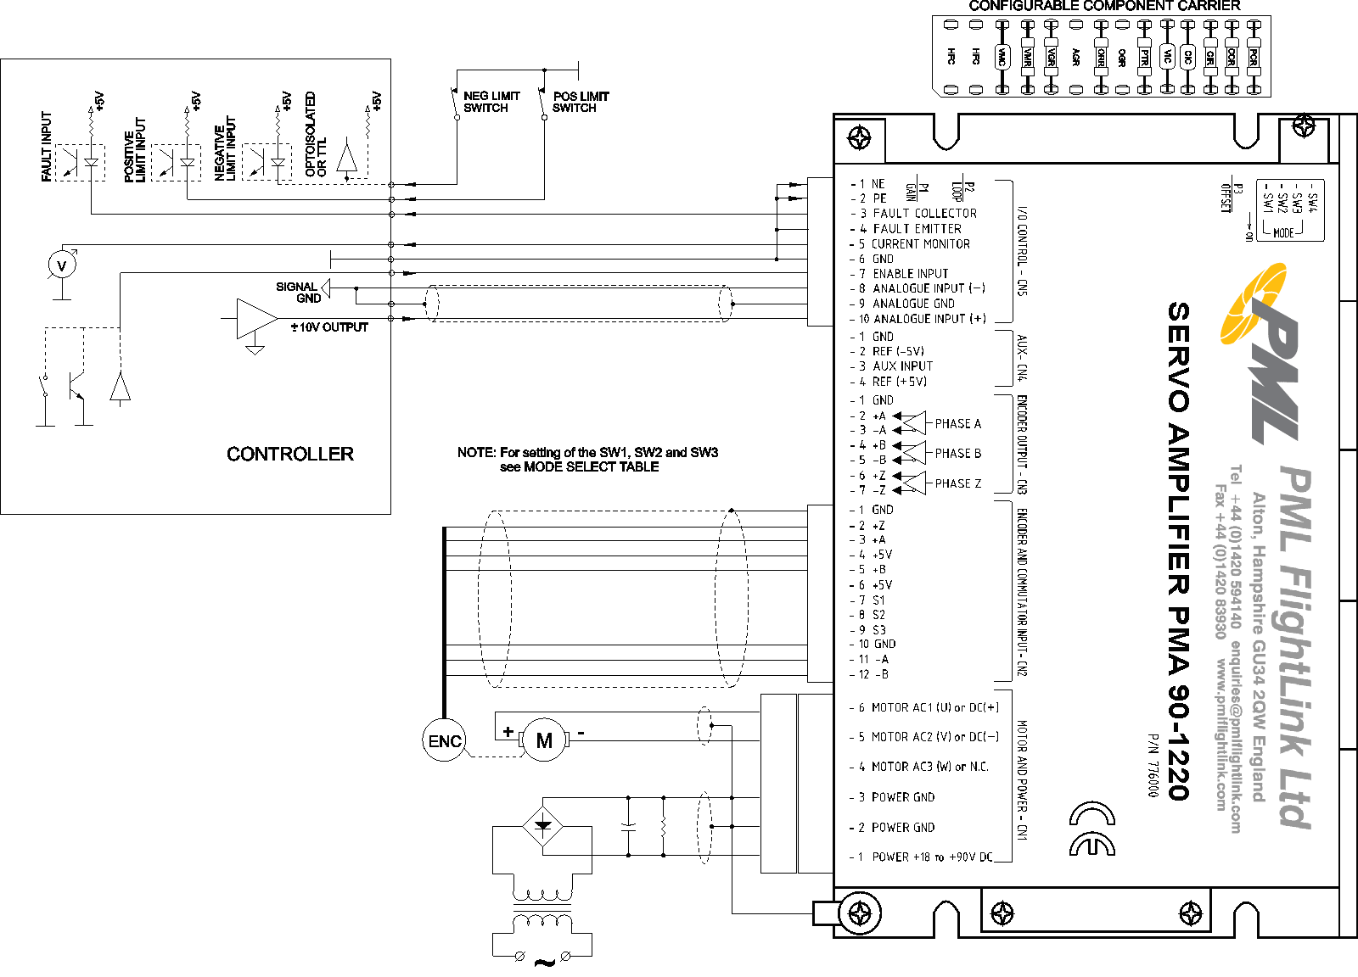

In ENCODER VELOCITY mode the motor speed is proportional to the voltage applied to the ANALOGUE INPUT. Encoder signals are used to produce a voltage proportional to the motor shaft speed. Set P1 INPUT GAIN fully CCW and P2 LOOP GAIN fully CCW. Power and enable the amplifier. Spin the motor shaft manually. If the motor “runs away” swap encoder wires +A/+B and -A/-B. In this mode, the configurable components CIC, CIR, and VIC must be optimised. P1 INPUT GAIN adjusts the ratio between ANALOGUE INPUT voltage and motor speed. P2 LOOP GAIN adjusts amplifier loop gain and bandwidth (system stability).
TYPICAL ANALOGUE POSITION MODE APPLICATION FOR BRUSHLESS MOTORS
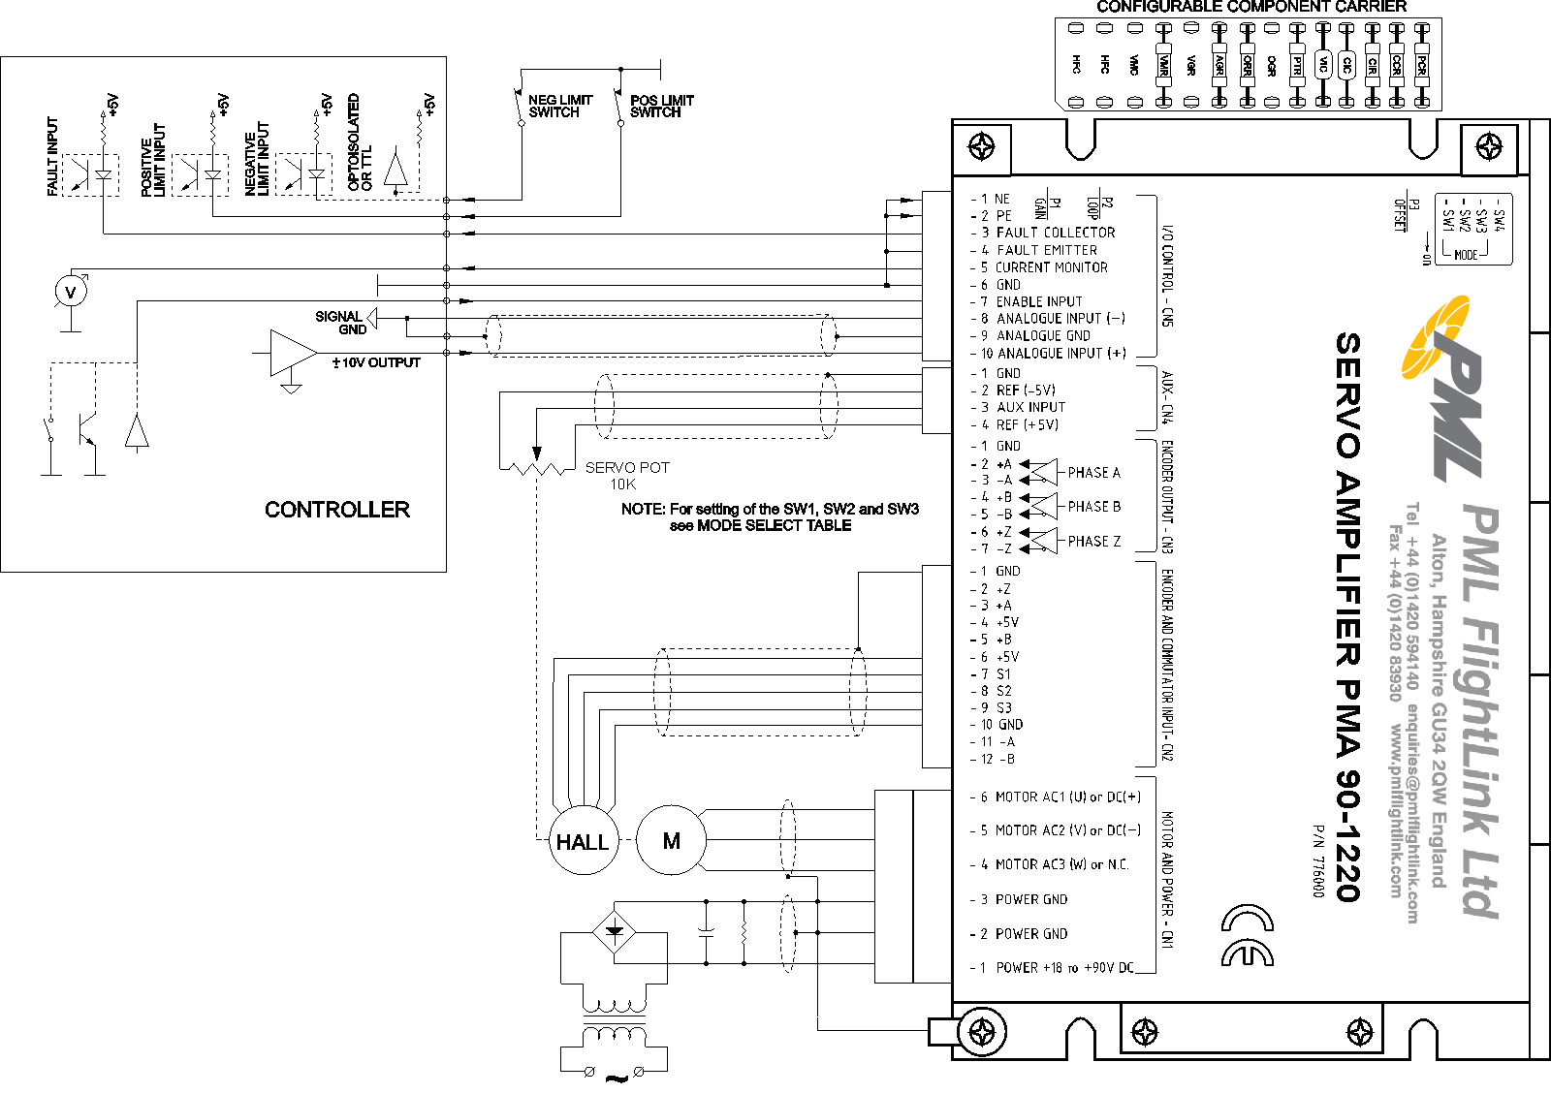

TYPICAL ANALOGUE POSITION MODE APPLICATION FOR BRUSHED MOTORS
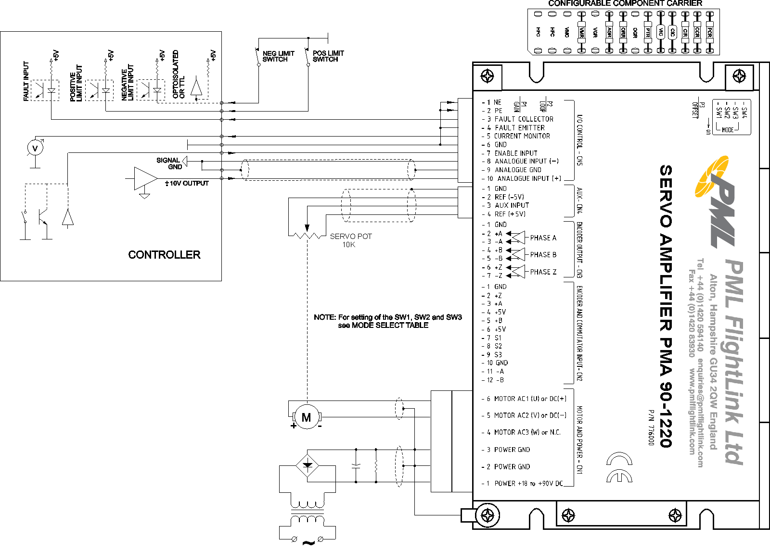

In ANALOGUE POSITION mode, an analogue 10K potentiometer is mechanically coupled to the positioned object. The potentiometer supplies voltage proportional to its position. This voltage is used as a feedback signal, keeping the motor (potentiometer) position proportional to the reference input voltage. Select AGR between 47K and 2M2 (±2V to ±50V input) depending on your application.
TYPICAL TACHO VELOCITY MODE APPLICATION FOR BRUSHLESS MOTORS
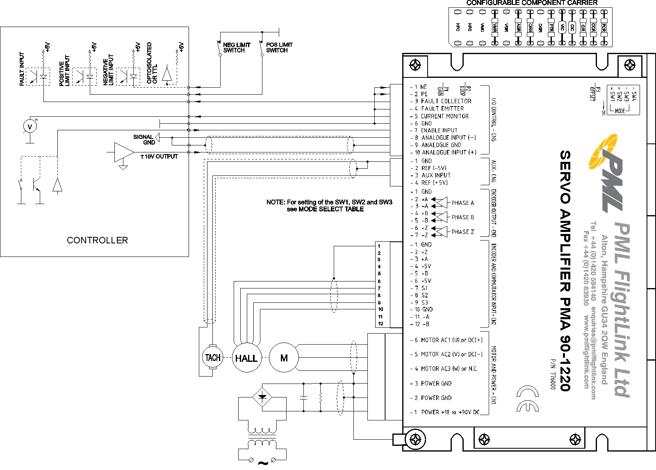

TYPICAL TACHO VELOCITY MODE APPLICATION FOR BRUSHED MOTORS
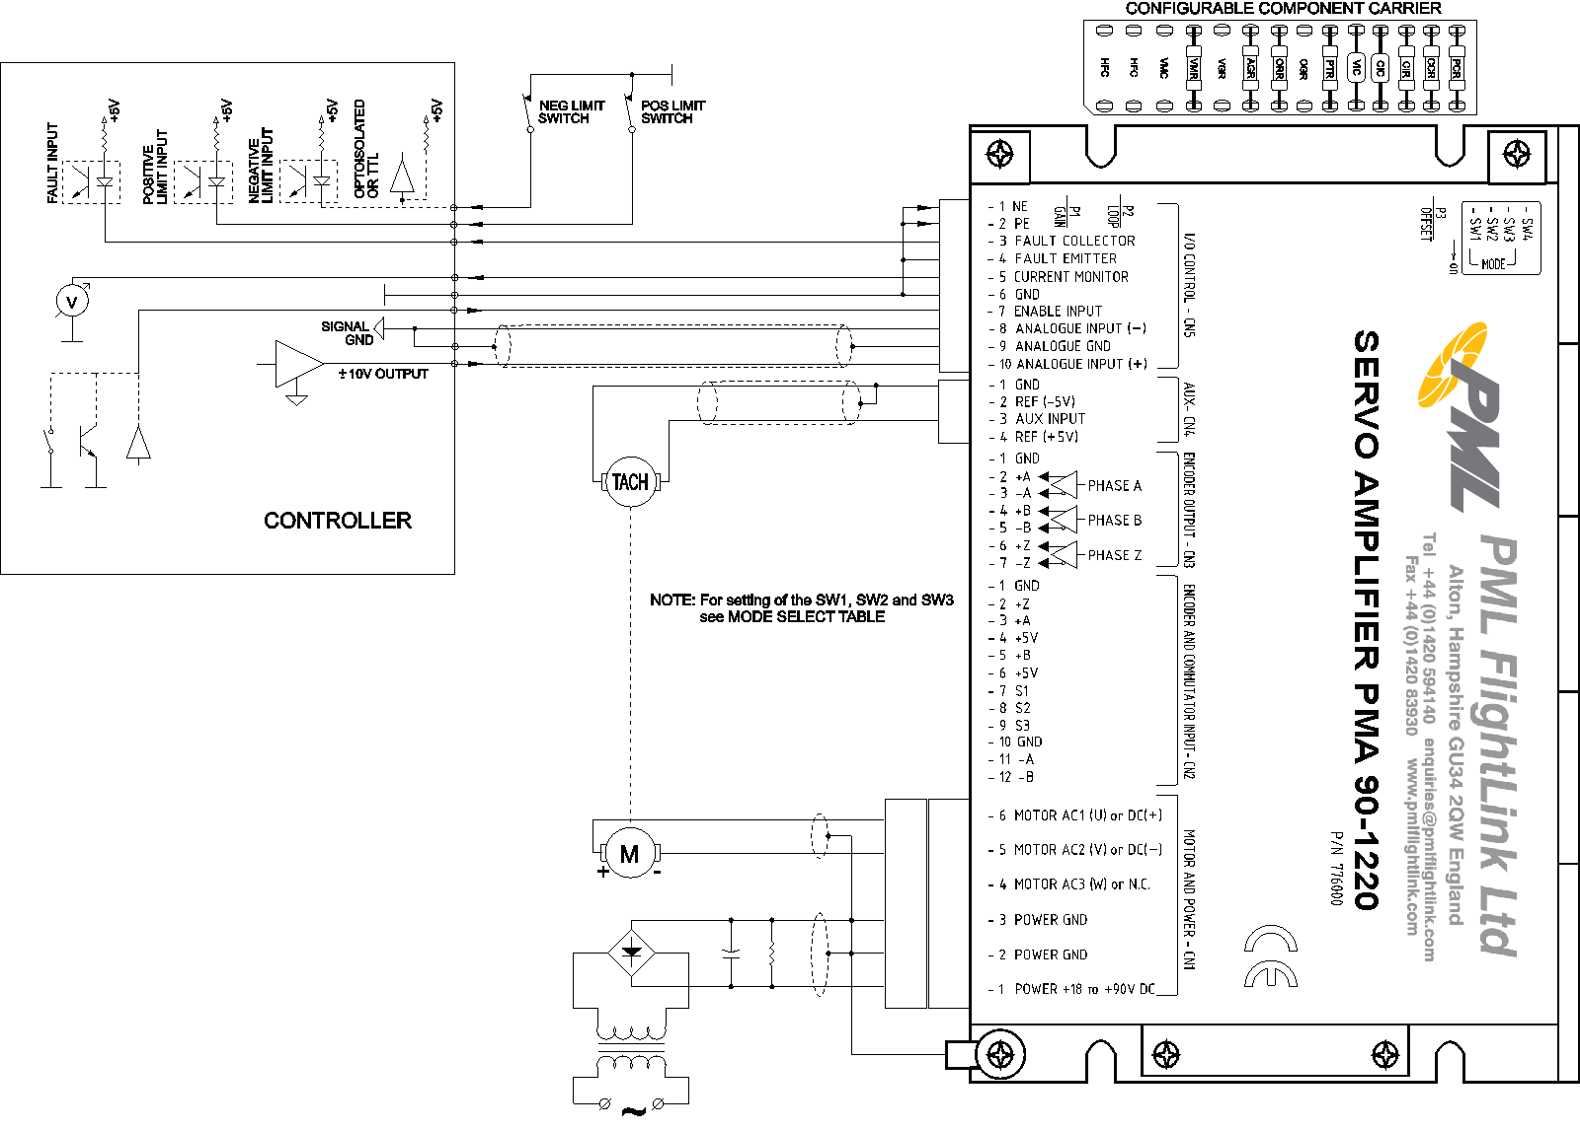
TACHO VELOCITY mode is only applicable for motors with tachometers. A tachometer produces a voltage proportional to the motor shaft speed. By using this voltage as a feedback, the amplifier keeps motor shaft speed proportional to the voltage applied to the ANALOGUE INPUT. Set P1 INPUT GAIN and P2 LOOP GAIN fully CCW. Power and enable the amplifier. Spin the motor shaft manually. If the motor “runs away”, reverse tachometer or motor polarity. In this mode the configurable components CIC, CIR, VIC and TGR must be optimised. P1 REF GAIN adjusts the ratio between ANALOGUE INPUT voltage and motor rotation speed. P2 LOOP GAIN adjusts amplifier loop gain and bandwidth (system stability).
TYPICAL HALL VELOCITY MODE APPLICATION
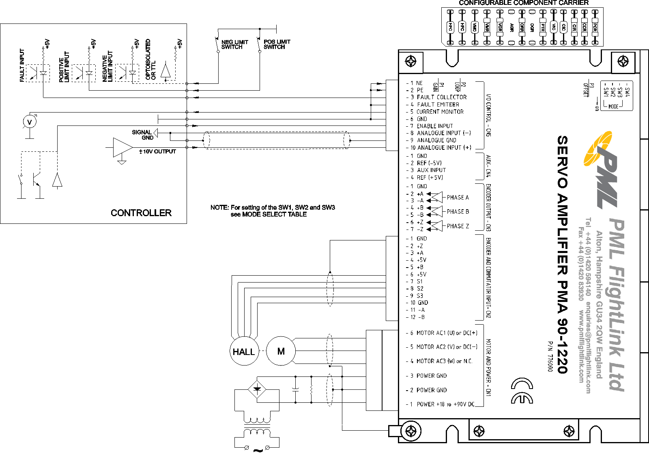
HALL VELOCITY mode is only applicable for brushless motors. Hall signals are used to produce a voltage proportional to the motor shaft speed. Using this feedback, the amplifier keeps motor shaft speed proportional to the reference voltage applied to the ANALOGUE INPUT. Proceed with Phasing and CIC optimisation procedures before switching to this mode. Select VMR, VMC and HFC according the tables given in Configurable Component Settings. Set P1 REF GAIN fully CCW and P2 LOOP GAIN fully CCW. Power and enable the amplifier. Spin the motor shaft manually. Switch SYNC if the motor “runs away” (see Mode Select table). P1 REF GAIN adjusts the ratio between ANALOGUE INPUT voltage and motor rotation speed. P2 LOOP GAIN adjusts amplifier loop gain and bandwidth (system stability). This mode will give better results if the motor work speed is more than 300 rpm.

STAND ALONE MODE APPLICATION

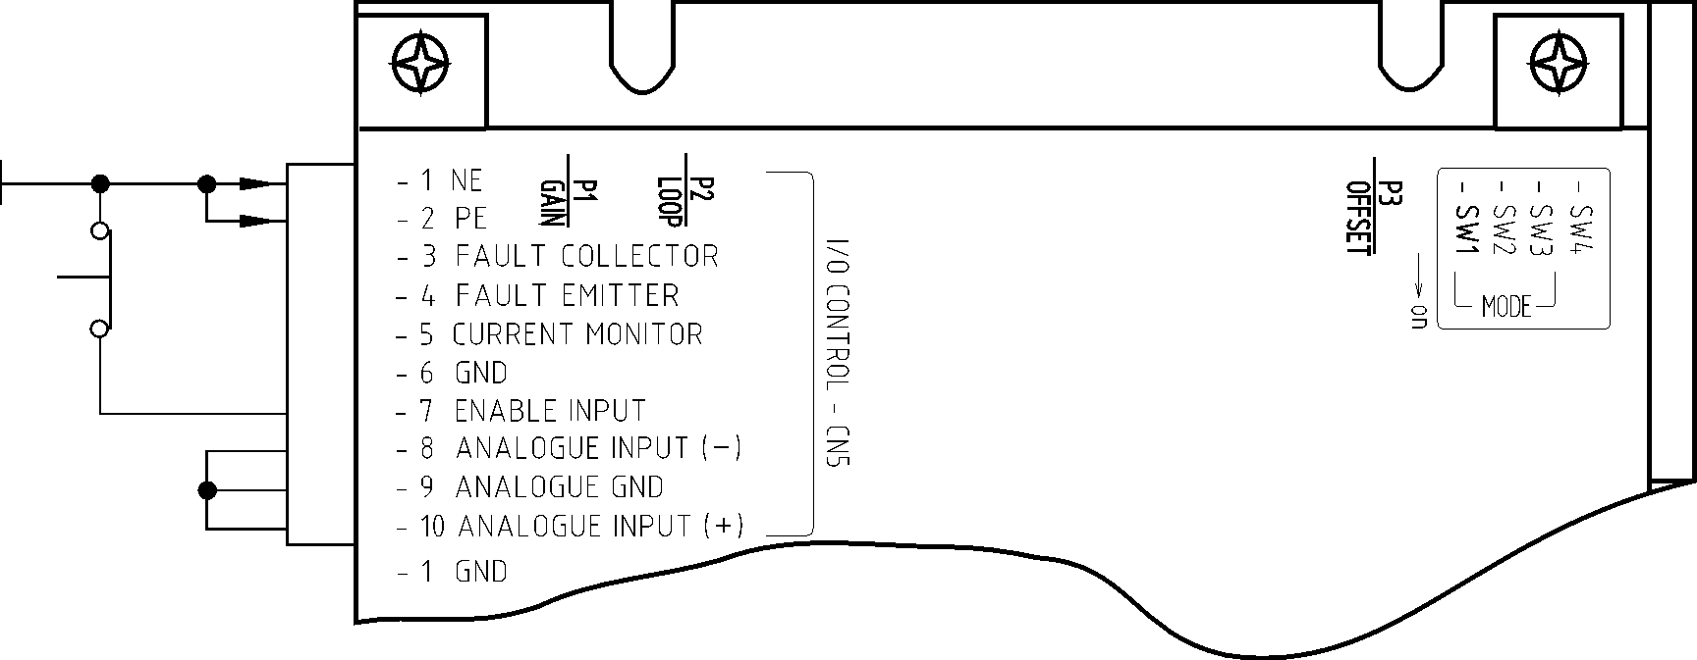

P3 OFFSET is used as an on board reference signal source driving servo amplifier output up to 100% (max range). For full output range set ORR=220K. Set P1 REF GAIN fully CCW. All remaining settings are the same as described for CURENT (TORQUE), ENCODER VELOCITY, TACHO VELOCITY or HALL VELOCITY modes.

