Features

- Motors supported:
- Brushless AC/DC 60/120° commutated
- Brushed DC
- Printed Armature DC

- Hall velocity mode

- Output current
- 12A peak, 8A continuous
- 20A peak, 12A continuous

- 12 to 90V single power supply

- 32-bit position, velocity, acceleration,
16-bit PID filter gain values

- Comprehensive motor output short-circuit protection:
- Output to output
- Output to ground
- Output to power

- Adjustable motor current limit

- Over/under voltage shutdown

- Overheating protection

- Emergency stop input

- Forward and reverse overtravel inputs

- Communication speed 19.2 - 115.2 KBPS

- Servo rate 2 kHz

- PWM frequency 40 kHz

- Command rate up to 1000/sec

- Encoder transition rate up to 500kHz.

- Small footprint (5” x 3.3” x 0.85”)

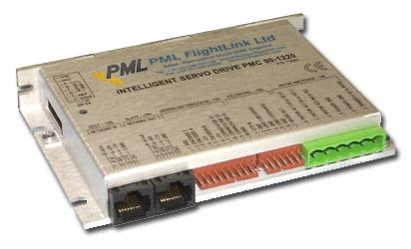

Description

The PMC 90 is a single-axis motion controller with integrated servo amplifier designed for applications using brushed DC motors, low inductance printed armature motors or brushless DC motors up to 750W.
No jumpers or setup is required to switch between types of motors. Trapezoidal brushless motor commutation is performed automatically if hall sensors are connected to the unit.
The PMC 90 can work without an encoder when driving brushless motors. In hall mode, it uses the hall sensors for motor feedback.
Up to 31 intelligent servo drives can be controlled over a multi-drop full duplex RS-485 network in a distributed motion control environment. Standard RJ-45 connectors and commercially available cables are used for daisy chaining of the modules.
The PMC 90 is equipped with various safety features such as short circuit protection for the motor and amplifier, over travel limit switch inputs, emergency stop input, over and under voltage shutdown. The maximum motor output current can be limited by setting of dipswitches.

TECHNICAL SPECIFICATIONS rated at 25ºC ambient, POWER (+)=60VDC, Load=250μH motor

POWER SUPPLY VOLTAGE | 12 to 90 V DC, 100V Absolute Maximum
MAX MOTOR OUTPUT CURRENT  Peak  Continuous | PMC 90-0812 PMC 90-1220  12A 20A  8A 12A
MAX MOTOR OUTPUT VOLTAGE | V_{out}= 0.96(POWER (+)) – 0.17(I_{out})
MIN LOAD INDUCTANCE | 200μH
PWM SWITCHING FREQUENCY | 40 kHz
Servo rate | 0.512 msec
Serial baud rate | 19.2 – 115.2 Kbps  (faster communication rates are possible at lower servo rates)
OPTIONAL OPEN COLLECTOR BRAKE OUTPUT  Max voltage applied to output  Max current load | 48V  0.3A
INPUTS  Encoder & Commutation  Digital Inputs | TTL with 1K pull-up to 5V  LOmin=-1V, HImax=48V
ENCODER | Quadrature with index
COMMUTATION | Hall sensors 60/120 º
INDICATORS  Red LED (two intensity levels) | Power ‘ok’ – low intensity  Servo ‘ok’ – high intensity
PROTECTION  Short circuit  Overheating shut off | Motor output to motor output  Motor output to POWER GND  Motor output to POWER (+)  Activated at 80 ºC
FIRE-SAFETY  Internal fuse | 10A Quick blow
POWER DISSIPATION (max) | 30W
THERMAL REQUIREMENTS  Storage temperature range  Operating temperature range | –30 to +85 ºC  0 to 45 ºC
MECHANICAL  Size  Weight | L=5.00”, H=3.30”, D=0.85”  0.55lb. (250gr.)
MATING CONNECTORS  Power & Motor  Inputs & Outputs  Encoder & Commutator  Communication | Magnum EM2565-06-VL or Phoenix MSTB 2.5/6-ST-5.08  Molex 22-01-3077 housing with 08-50-0114 pins (7 pcs.)  Molex 22-01-3107 housing with 08-50-0114 pins (10 pcs.)  8 pin RJ-45

DIMENSIONAL DRAWING in millimetres
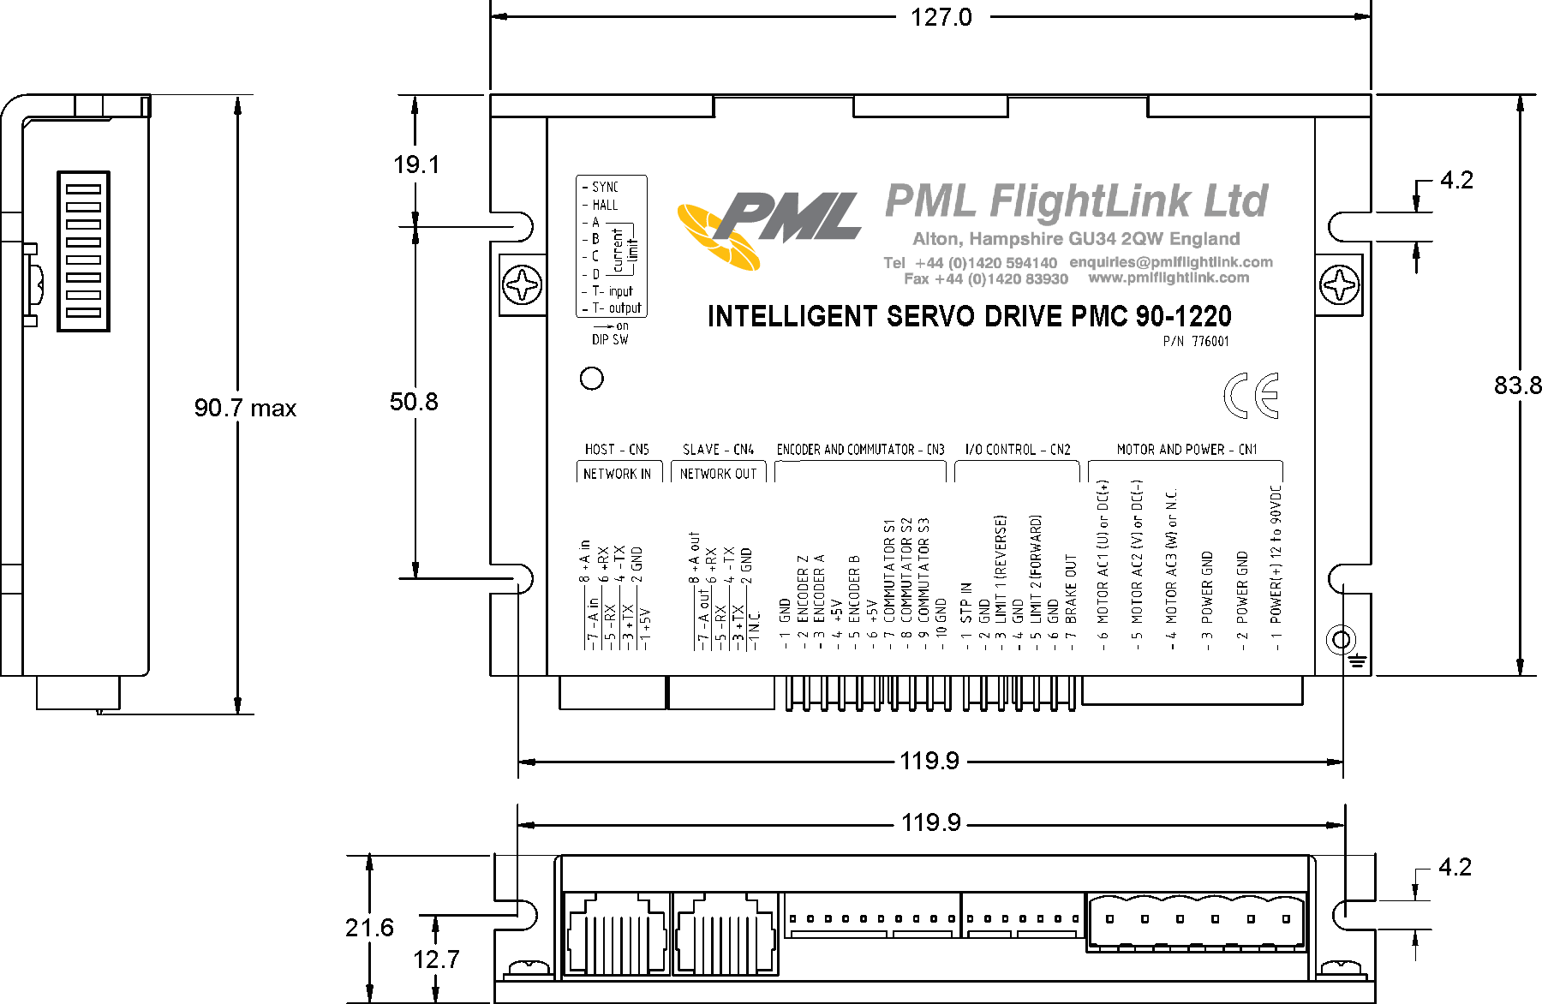

SERVO DRIVE LAYOUT

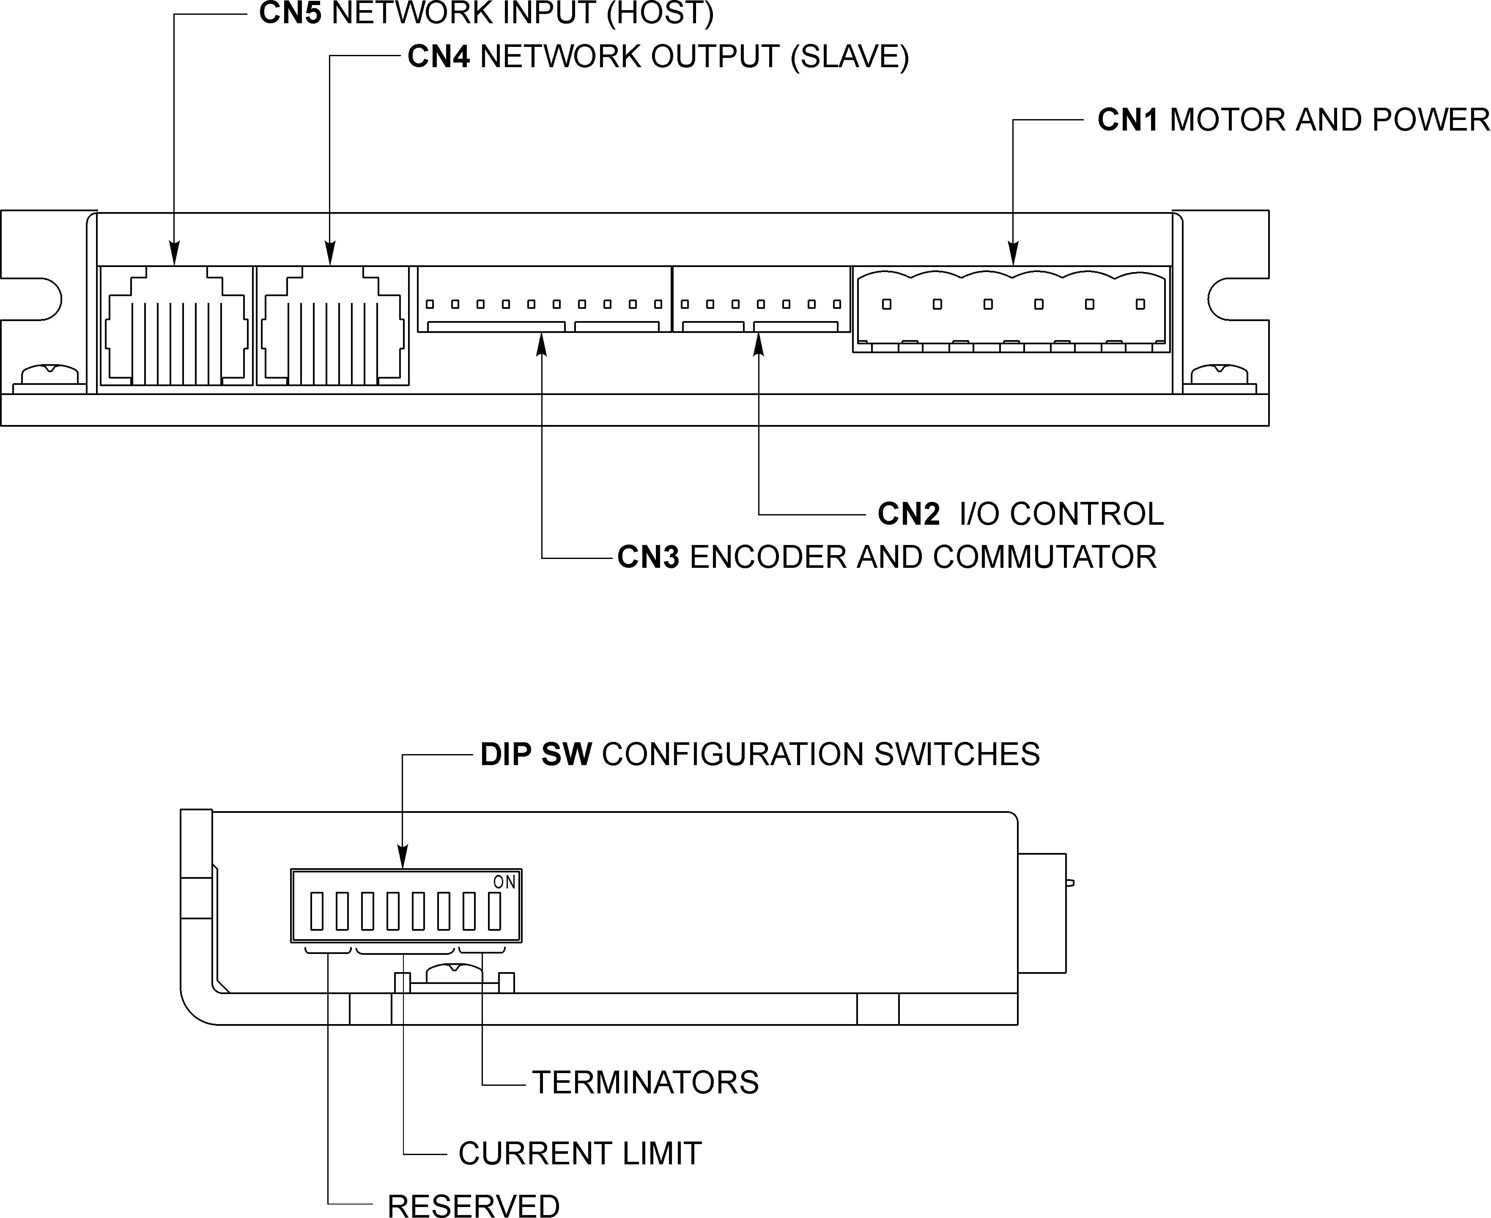

ORDERING GUIDE

PART NUMBER | MODEL | DESCRIPTION
776002 | PMC 90-0812 | Intelligent Servo Drive 8A cont. 12A peak
776001 | PMC 90-1220 | Intelligent Servo Drive 12A cont. 20A peak
776003 | PMC 90 CN | Mating connector kit
CONNECTORS AND PINOUT

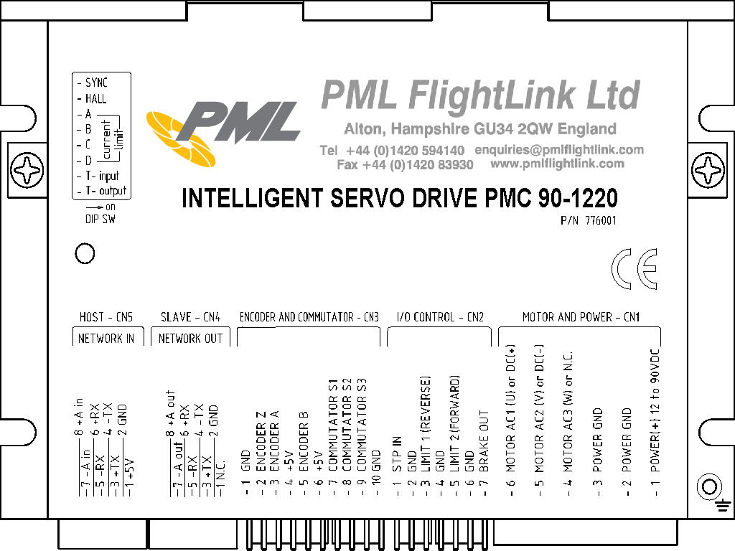

DIP SW – DIP SWITCH
SW | SIGNAL | DESCRIPTION | FACTORY SETTING
1 | T-out | Transmit line terminator | OFF
2 | T-in | Receive line terminator | OFF
3 | CL-D | Current limit switch | OFF
4 | CL-C | Current limit switch | ON
5 | CL-B | Current limit switch | ON
6 | CL-A | Current limit switch | ON
7 | HALL | Hall mode (ON) or encoder mode | ON
8 | SYNC | Hall combinations direction | ON

CN1 – POWER AND MOTOR CONNECTOR
PIN | SIGNAL | DESCRIPTION
1 | POWER (+) | 12 – 90V power supply, positive terminal
2 | POWER GND* | Power supply ground
3 | POWER GND* | Power supply ground
4 | AC3 or NC | Output to motor  Phase 3 terminal for brushless motor  Not connected for brushed motor
5 | AC2 or DC (-) | Output to motor  Phase 2 terminal for brushless motor  Negative terminal for brushed motor
6 | AC1 or DC (+) | Output to motor  Phase 1 terminal for brushless motor  Positive terminal for brushed motor
CN2 – I/O CONTROL
PIN | SIGNAL | DESCRIPTION
1 | STP IN | Stop input (disable servo amplifier)
2 | GND* | Signal ground
3 | REVERSE LIMIT | Reverse limit input
4 | GND* | Signal ground
5 | FORWARD LIMIT | Forward limit input.
6 | GND* | Signal ground
7 | BRAKE OUT | Brake output (optional). Open collector output  48V/0.3A.

CN3 – ENCODER AND COMMUTATOR
PIN | SIGNAL | DESCRIPTION
1 | GND* | Encoder ground
2 | ENCODER Z | Encoder index
3 | ENCODER A | Encoder phase A
4 | +5V | Encoder power supply
5 | ENCODER B | Encoder phase B
6 | +5V | Commutator power supply
7 | COMMUTATOR S1 | Hall sensor #1
8 | COMMUTATOR S2 | Hall sensor #2
9 | COMMUTATOR S3 | Hall sensor #3
10 | GND* | Commutator ground

CN4 – NETWORK OUT (SLAVE)
PIN | SIGNAL | DESCRIPTION
1 | N.C. | Not connected
2 | GND* | Interface ground
3 | +TX | (+) Transmit data
4 | -TX | (-) Transmit data
5 | -RX | (-) Receive data
6 | +RX | (+) Receive data
7 | -A out | (-) Address output
8 | +A out | (+) Address output

CN5 – NETWORK IN (HOST)
PIN | SIGNAL | DESCRIPTION
1 | +5V | RS-232 adapter power supply
2 | GND* | Interface ground
3 | +TX | (+) Transmit data
4 | -TX | (-) Transmit data
5 | -RX | (-) Receive data
6 | +RX | (+) Receive data
7 | -A in | (-) Address input
8 | +A in | (+) Address input
SAMPLE APPLICATION using AC (brushless) motor – HALL mode

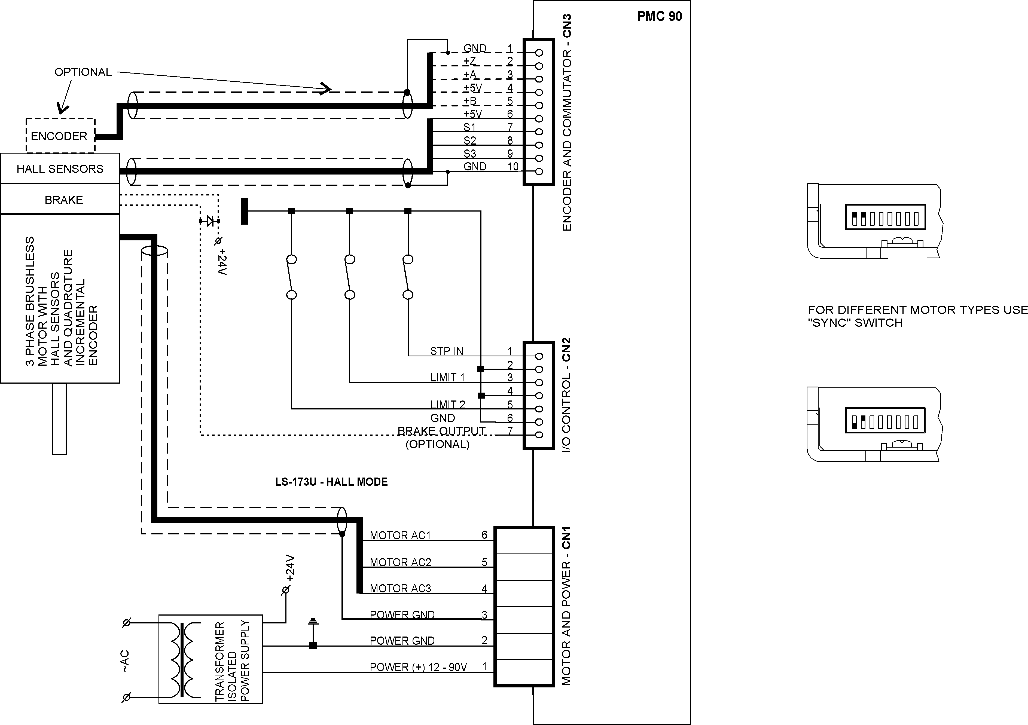

SAMPLE APPLICATION using AC (brushless) motor – ENCODER mode

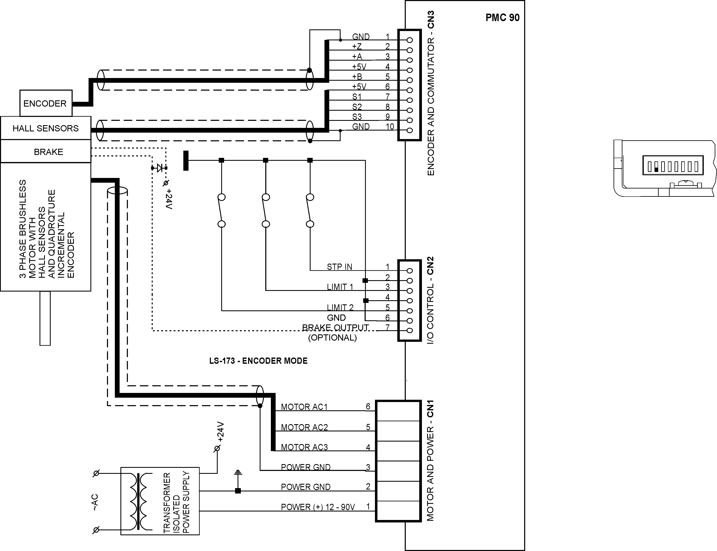

SAMPLE APPLICATION using DC (brushed) motor

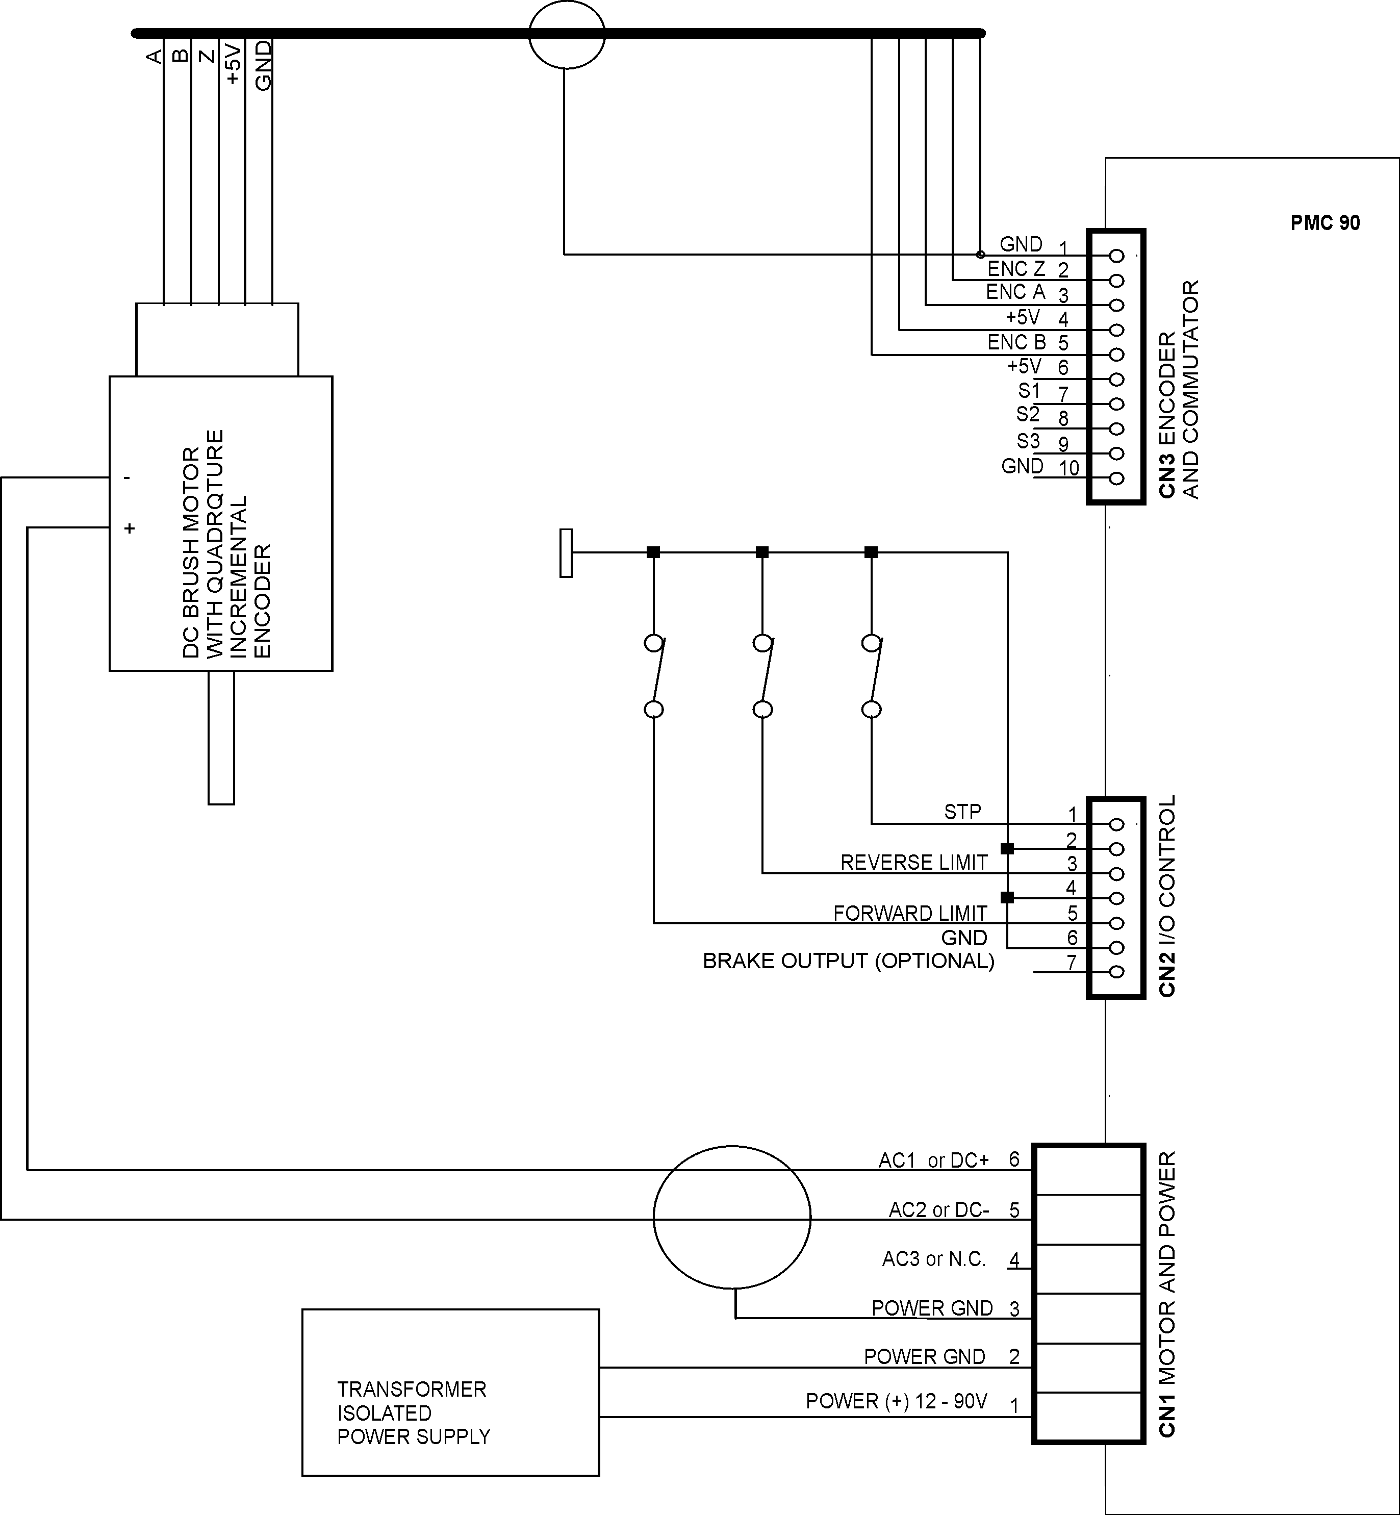

PMC 90 QUICK START GUIDE

Hardware Setup

- Connect power supply (12 to 90 V DC) to PMC 90.
- Connect your motor, encoder, Hall sensors and any other I/O you may have.
- Connect RS-232 adapter and RJ-45 network cable between PMC 90 and your host computer.

Software Installation

1. Installation and using the Distributed Control Network Utility

A. Installation
- Insert the Distributed Control Network Utility installation disk into the floppy drive.
- Select Run from the Windows 95/98/NT Start menu.
- Type a:\dcnsetup and then click OK (a: represents the drive letter).
- The installation wizard will guide you through the setup process.

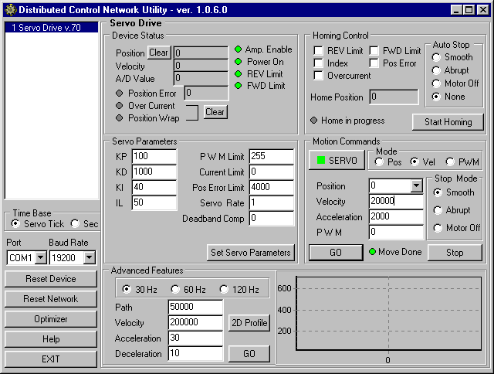

B. Initial Connection to the Host

Turn on the power supply.
- Run the Distributed Control Network Utility.
- Choose the proper COM port
- Click “SERVO” button.
- Click “GO” button. The motor should rotate slowly in positive direction. Click “Stop” to interrupt the motion. More information about using LDCN utility is available in LDCN Help.

2. Installation and using the Motion Control Centre

A. Installation
- Insert the Distributed Control Network Utility installation disk into the floppy drive.
- Select Run from the Windows 95/98/NT Start menu.
- Type a:\dcnsetup and then click OK (a: represents the drive letter).
- The installation wizard will guide you through the setup process.

B. Initial Connection to the Host

Turn on the power supply.
- Run the Distributed Control Network Utility.
- Choose the proper COM port
- Click “SERVO” button.
- Click “GO” button. The motor should rotate slowly in positive direction. Click “Stop” to interrupt the motion. More information about using DCN utility is available in DCN Help.
PMC 90 ARCHITECTURE

Overview

The PMC 90 Intelligent Servo Drive is a highly integrated servo control module including a motion controller, servo amplifier, serial communication interface, optical encoder interface, limit switch inputs, and protection circuit (short circuit, under and overvoltage, overcurrent and software controlled current limit). The Servo Drive is designed so that up to 31 controllers can be daisy-chained and connected directly to a single standard serial port (RS-232 adapter may be necessary).

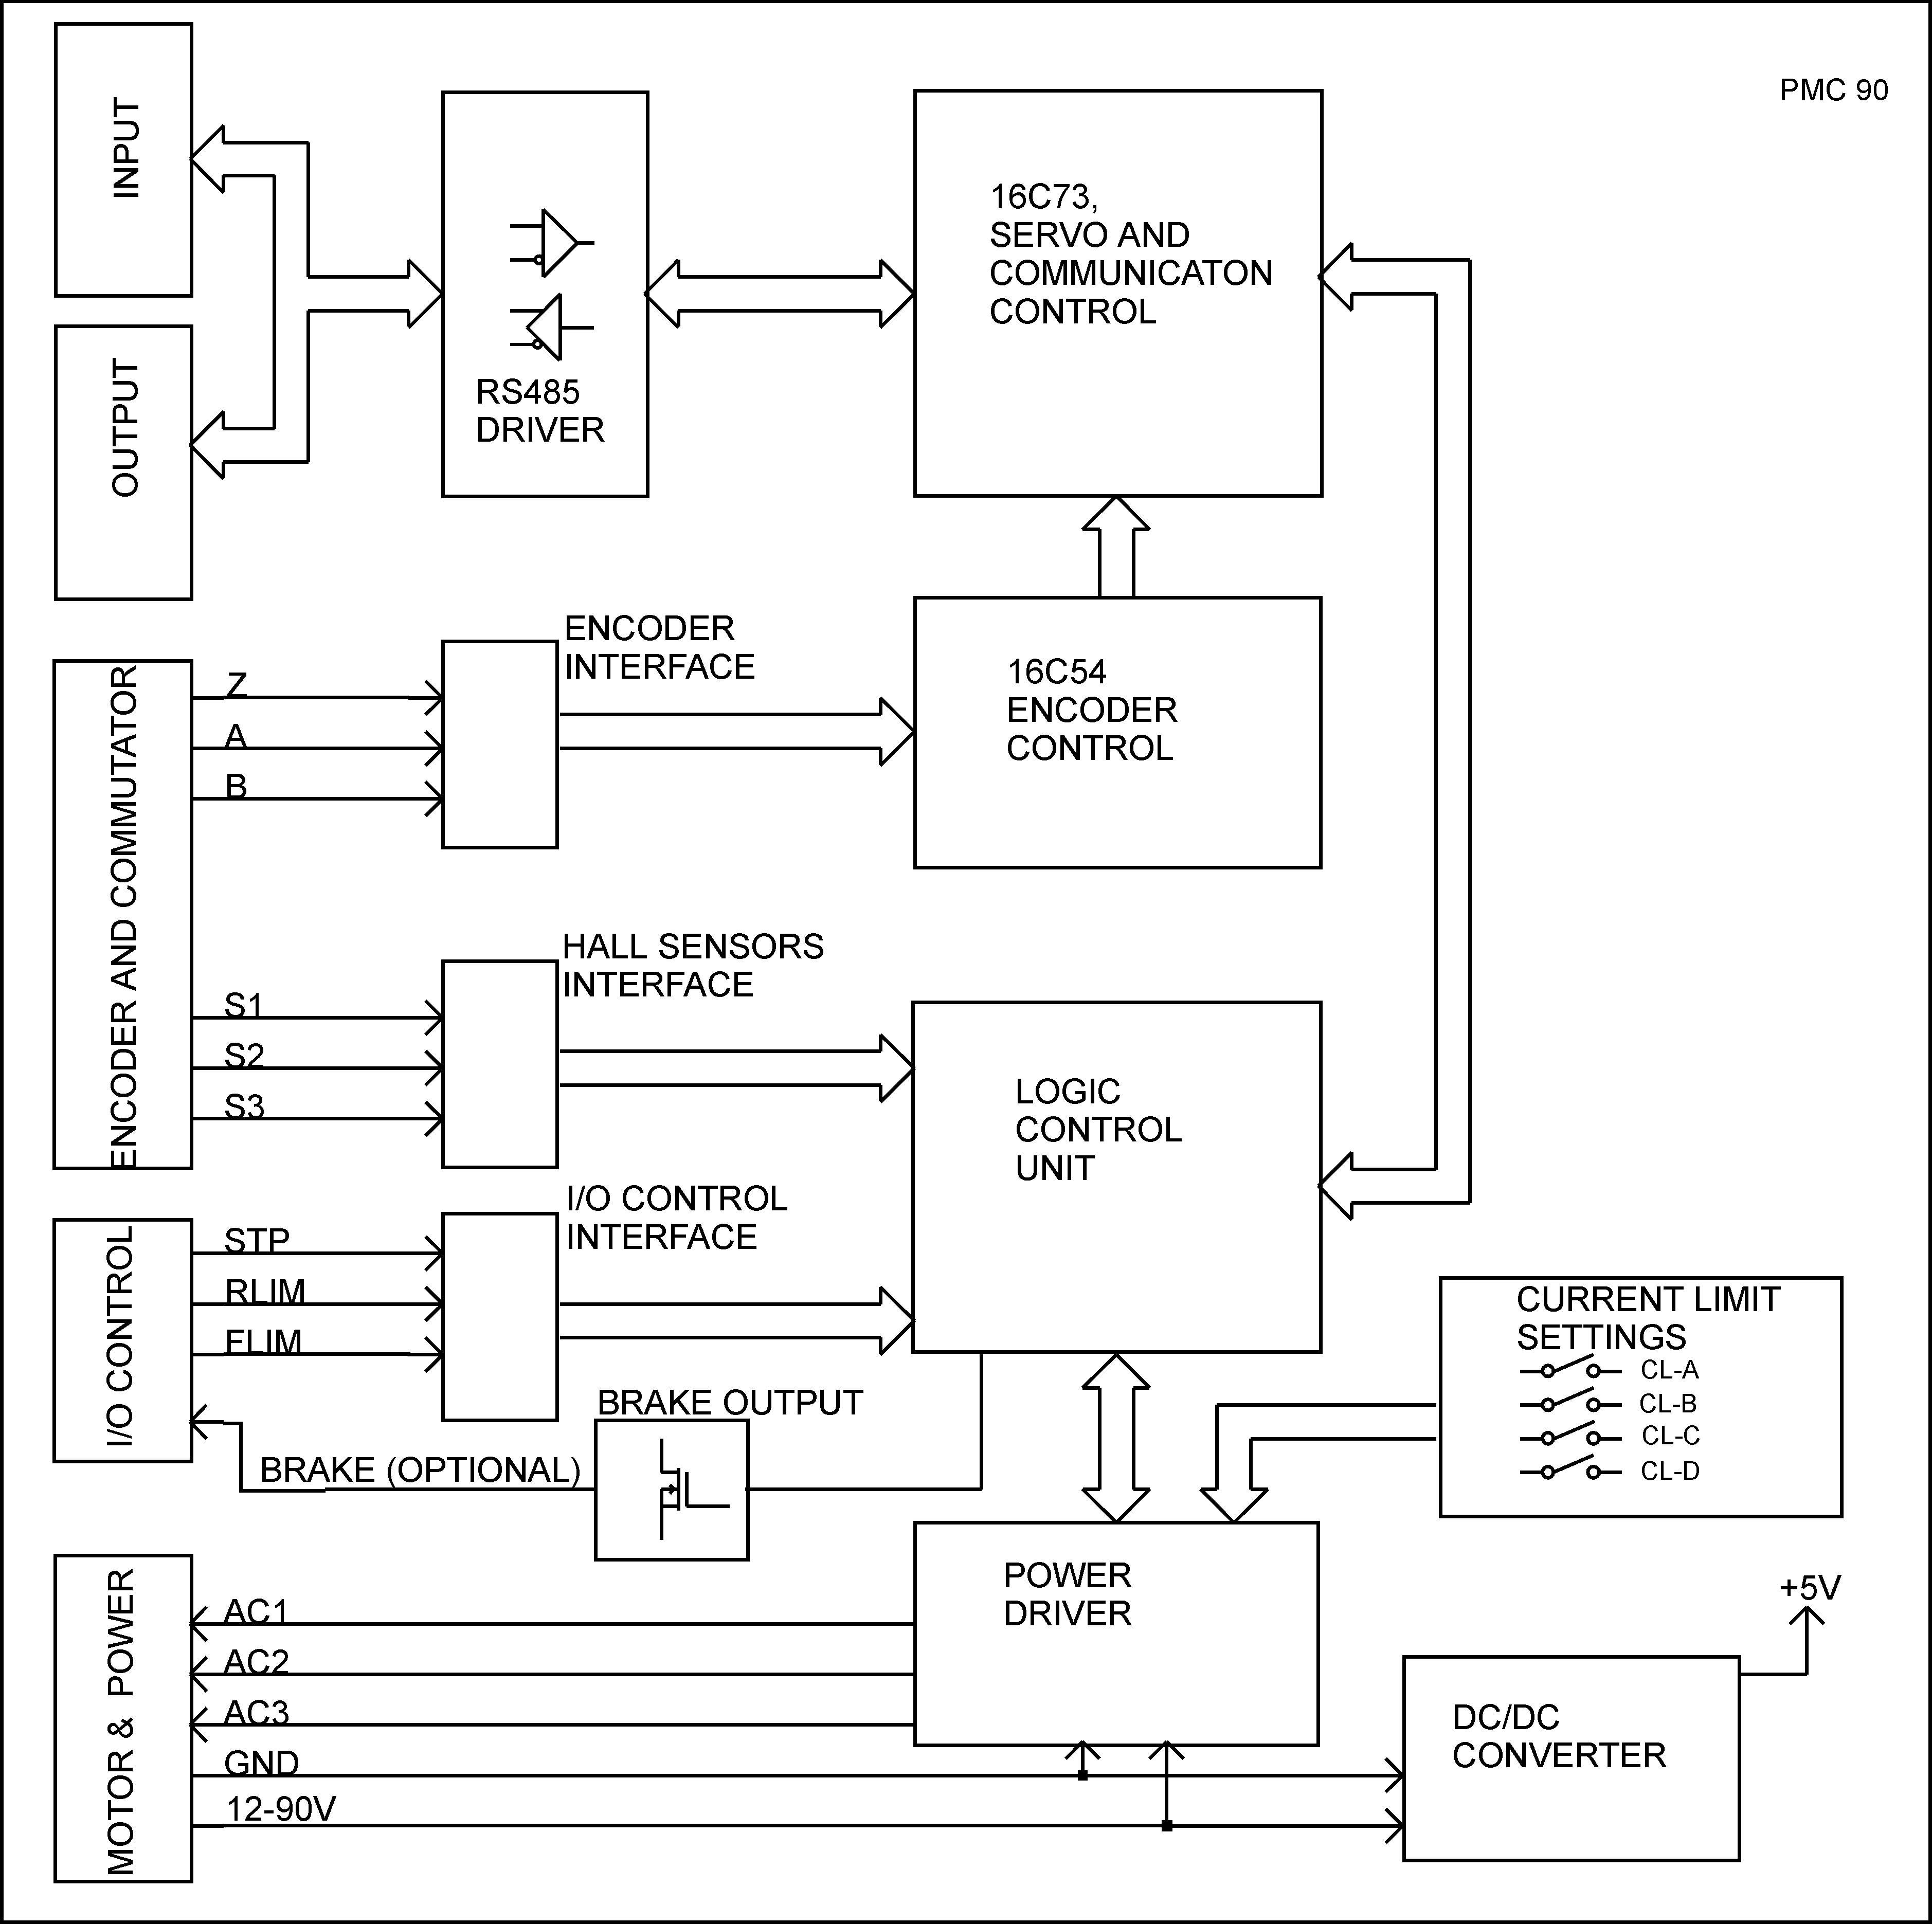
Functional Diagram

Encoder Input
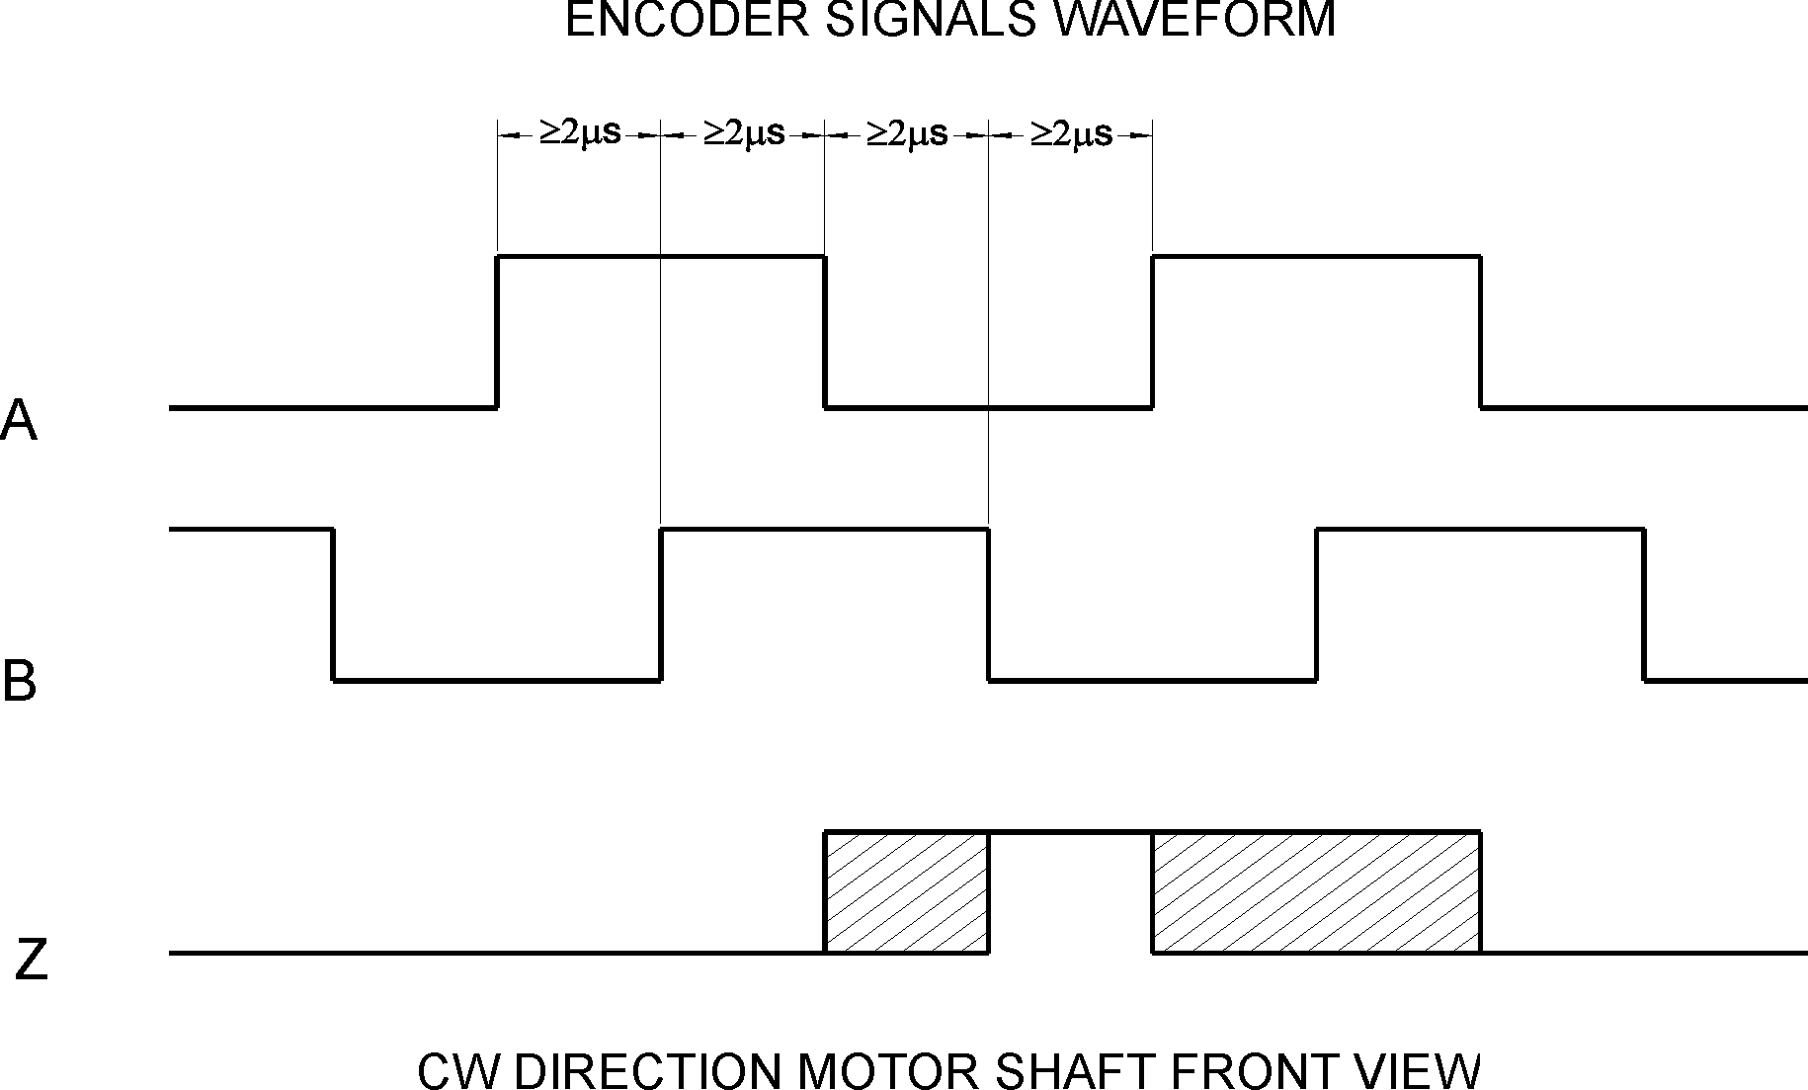
The encoder interface accepts two square wave inputs, CH_A, CH_B and Index from an incremental encoder. Ideally, these square waves are 50% duty cycle and exactly +/-90 degrees out of phase. In any case, the time between encoder state transitions should be not less than 2 µsec. With ideally formed encoder pulses, this would correspond to a 500-line encoder (2000 counts/rev) rotating at 15,000 RPM.

CW MOTOR DIRECTION

All encoder inputs are with pull-up resistors 1K to +5V.

Encoder and Hall Inputs

Hall Inputs
Hall sensor inputs are placed on the same connector as encoder inputs. All hall sensors are with pull-up resistors 1K to +5V. 60°/120° hall sensors may be used

Digital Inputs
There are 3 digital inputs - STP IN, FORWARD LIMIT and REVERSE LIMIT. STP IN may be used only as “STOP” input. Limit inputs may be used as “HOME” switches, limit switches or as general-purpose inputs. (Refer to “I/O Control” and “Set Homing Mode” commands in the “Command Description” section in this document) All are with pull-up resistors 1K to +5V.

Limit Switches and Stop Input
Brake Output
Brake is released (brake output is “on”) when Power_on (bit3 of Status byte) and Pic_ae (bit0 of Stop command data byte) are set to 1.

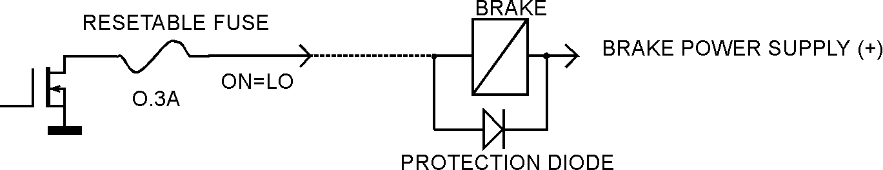
Brake Output

Brake will be engaged (Brake output is “off”) if:

- STP IN is open;
- Overvoltage;
Overcurrent;
- Motor short;
- Overheat;
- Position error exceeds the position error limit.

Note: For additional information refer to “Status bits and LED”, “Status byte and Auxiliary status byte” and “Stop” command description, sections of this document. If Power Driver is OK, brake will be released after Pic_ae 0 to 1 transition.

Dip Switch
Dip switch is used for setting overcurrent limit and terminator control (refer to “Overcurrent DIP Switch Setting” of “Safety Features” in this document) Two of switches ,T-in and T-out, are used for connecting terminators to receive and transmit lines. SW-1 and SW-2 are factory reserved and must be set to ON.

Serial Command Interface
Serial communication with the PMC 90 drives adheres to a full-duplex (4 wire) 8 bit asynchronous protocol with one start bit, followed by 8 data bits (lsb first), followed by a single stop bit.
The communication protocol of the PMC 90 also supports a full-duplex multi-drop RS-485 interface that allows multiple PMC 90 intelligent servo drives to be controlled over a single RS-485 port. In this case, the host sends commands over its RS-485 transmit line and receives all status data back over the shared RS-485 receive line.
The command protocol is a strict master/slave protocol in which the host master sends a command packet over the command line to a specific PMC 90 slave. The data are stored in the buffer of the PMC 90 until the end of the current servo cycle (0.512 msec max.) and then the command is executed. The servo drive then sends back a status packet. Typically, the host does not send another command until a status packet has been received to insure that it does not overwrite any previous command data still in use.
Each command packet consists of following:
Header byte (0xAA)
Address byte - individual or group (0x00 - 0xFF)
Command byte
0 - 15 data bytes
Checksum byte
The command byte is divided into upper and lower nibbles: the lower nibble is the command value; the upper nibble is the number of additional data bytes, which will follow the command byte. The checksum byte is 8 bit sum of the address byte, the command byte and the data bytes. The number of data bytes depends on the particular command chosen. After a command is issued, the corresponding controller will send back a status packet consisting of:
Status byte
0-16 optional bytes of status data
Checksum byte
The status byte contains basic status information about the PMC 90, including a checksum error flag for the command just received. The optional data bytes may include data such as the position, velocity, etc. and are programmable by the host. The checksum byte is the 8 bit sum of the status byte and the additional optional status data bytes. All 16-bit and 32-bit data is send with the least significant byte first.

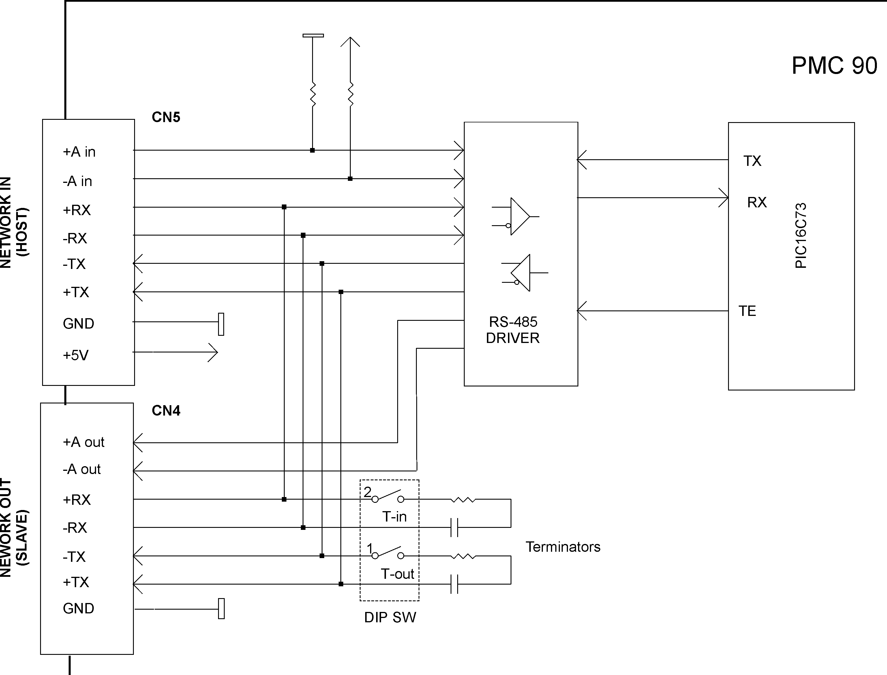
Servo Driver Serial Interface

Addressing
Rather than having to hard-wire or switch-select the address of each PMC 90 servo drive, the host dynamically sets the address of each PMC 90 with the aid of the daisy-chained “A in” and “A out” lines. This allows additional PMC 90 controllers to be added to an RS-485 network with no hardware changes. On power-up, “A in” of the first PMC 90 is pulled low, its communication is enabled and the default address is 0x00. When the Set Address command is issued to give this PMC 90 new unique address, it will lower its “A out” pin. Connecting “A out” pin to the “A in” pin of the next servo drive in the network will enable its communication at default address of 0x00. Repeating this process allows a variable number of controllers present to be given unique addresses. See “Initialising procedure and programming examples for PMC 90” later in this document.
Group Addresses
In addition to the individual address, each controller has a secondary group address. Several PMC 90 controllers may share a common group address. This address is useful for sending commands, which must be performed simultaneously by a number of drivers (e.g. Start motion, Set Baud Rate, etc.). When a PMC 90 receives a command sent to its group address, it will execute the command but not send back a status packet. This prevents data collisions on the shared response line. When programming group addresses, however, the host can specify that one member of the group is the “group leader”. The group leader will send back a status packet just like it would for a command sent to its individual address. The group address is programmed at the same time as the unique individual address using the Set Address command.

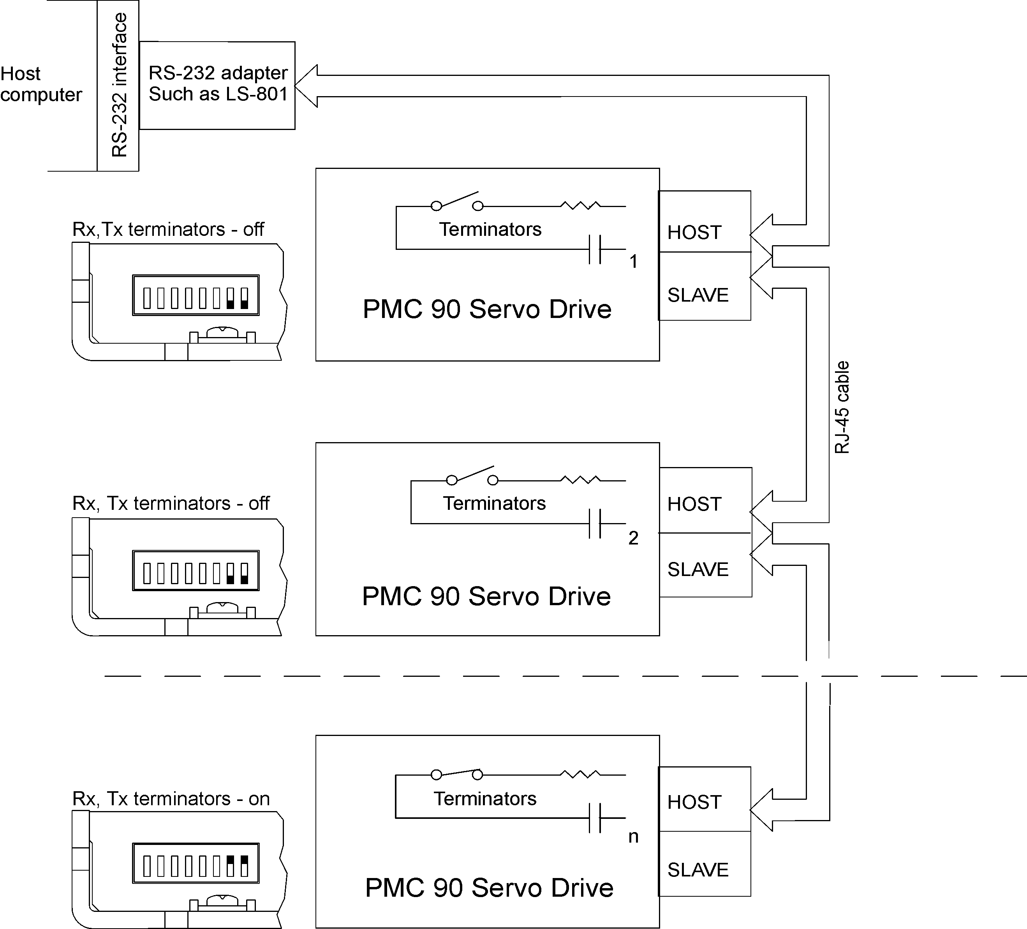
Multiple Controller Configuration

Communication Rate
The default baud rate after power-up is 19.2 Kbps. Baud rates up to 115.2 Kbps may be used at maximum servo rate. After communication has been established with all servo drives on a single network, the baud rate may be changed to a higher value with the Set Baud Rate command.

Servo Control
PMC 90 uses a “proportional-integral-derivative”, or PID filter. The PWM signal is a square wave with 51.2 µsec period and varying duty cycle. A PWM value of 255 corresponds to 100% and a value of 0 corresponds to 0%. Usually, PWM value greater than 250 is not recommended. The position, velocity and acceleration are programmed as 32-bit quantities in units of encoder counts for servo ticks. For example, a velocity of one revolution per second of a motor with a 500 line encoder (2000 counts/rev) at a tick time of 0.512 msec. would correspond to a velocity of 1.0240 counts/tick. Velocities and accelerations use the lower 16 bits as a fractional component so the actual programmed velocity would be 1.024 x 216 or 67,109. An acceleration of 4 rev/sec/sec (which would bring us up to the desired speed in ¼ sec) would be 0.0021 counts/tick/tick; with the lower 16 bits the fractional component, this would be programmed as 0.0021 x 216 or 137. Position is programmed as a straight 32-bit quantity with no fractional component. Note that if the servo rate divisor is modified, the time dependent velocity and acceleration parameters will also have to be modified.

PWM Mode Operation
If the position servo is disabled, the motor is operated in a raw PWM output mode and no trapezoidal or velocity profiling is performed. In this mode, a user specified PWM value is outputted directly to the amplifier. Command position is continually updated to match the actual position of the motor and there will be no abrupt jump in the motor’s position when position or velocity modes are entered. Also while the position servo is disabled, the command velocity is continually updated to match the actual velocity of motor. Thus, when velocity mode is entered, there will be no discontinuity in the motor’s velocity. (Trapezoidal profile motions, however, will still force the motor to begin at zero velocity.).

Connecting Brushless or Brushed Type Motor
PMC 90 is capable of driving brushless commutated (AC) and brushed (DC) type motors. No jumpers or other setting are required. If there are no Hall sensors connected to “ENCODER AND COMMUTATOR”, PMC 90 drives the motor as brushed (DC) type. The positive motor lead should be connected to “AC1 or DC+” terminal and negative to “AC2 or DC-“ terminal of “MOTOR AND POWER” connector. If Hall sensors are detected, PMC 90 performs commutation according to their state.
Often, connecting the brushless motor phases is difficult because of the different terms and signal names, which different manufactures are using. Here is a simple procedure that may be used.
Connect the motor commutation sensors to PMC 90 “ENCODER AND COMMUTATOR” connector according to the next table with most common manufacture signal names.

PMC 90 Hall Sensor signal | Motor manufacture signal name
S1 | R | U | A | S1
S2 | S | V | B | S2
S3 | T | W | C | S3

Connect the commutator power leads to GND and +5V. Connect the encoder and its power lines to the same connector. Connect the three motor leads to “AC1 or DC+”, “AC2 or DC-“, “AC3 or NC” of PMC 90 “MOTOR AND POWER” connector using the same order as for the commutation sensors. Power up PMC 90. Initialise the controller. Rotate motor shaft CW (ClockWise) by hand and check if the motor position is increasing. If motor position is not changing or it is decreasing, check encoder connection. Set the Drive in PWM mode. Start the motor with PWM for example 5 (this value might be enough or not depending on motor used) Set PWM to –5. If the phasing is correct the motor shaft should rotate CW (CCW) smoothly without any jerks. Otherwise try different motor leads connection. There are only six combinations and it is recommended to try all of them. Usually only one works fine. If you find more than one, try to run the motor at higher speed. Set the Drive in velocity mode and start the motor in CW direction. If the motor runs away, directions of motor and encoder are opposite. To change the motor direction exchange S1 with S3 and AC1 with AC2. To change the encoder direction exchange A and B phase wires.
Safety Features

To protect both the user device and the controller, PMC 90 is equipped with various safety features.

STP IN – Stop Input
For normal operation STP signal must be “low”. If it is “high” it will disable the Power Driver and set status byte bit 3 (Power_on) to zero.

Undervoltage/Overvoltage Protection
PMC 90 is protected against power supply under/overvoltage. In case the power supply is below 12V hardware reset is generated. More then 91V will disable the Power Driver and set status byte bit 3 (Power_on) to zero.

Overcurrent Protection
A protection circuit monitors the output current of the motor and limit to a value set by dipswitch. If the motor is overloaded for less than 100 ms, the output current is limited to the selected level. Power Driver will be disabled if the motor is overloaded for more then 100 ms. To set CL (current limit) use the table:

Overcurrent DIP Switch Settings

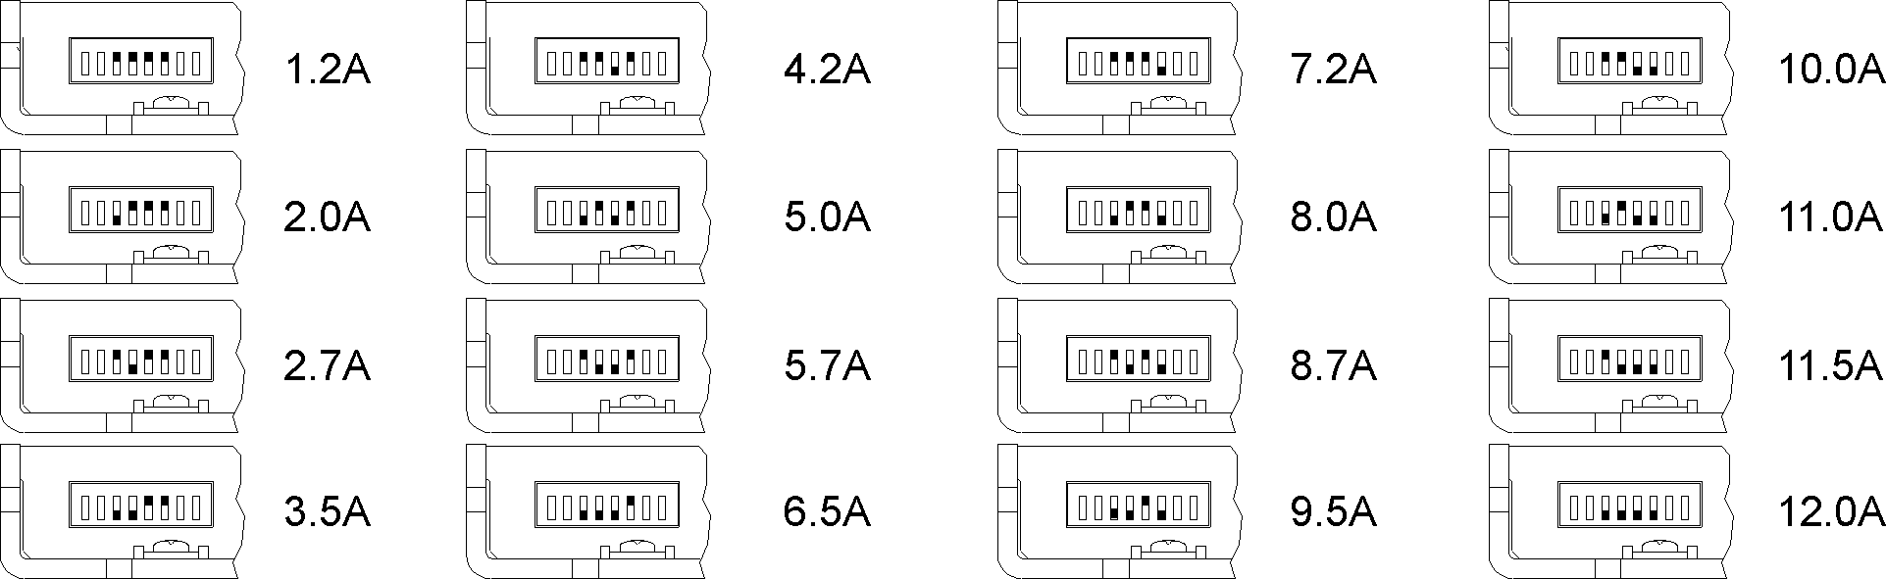

Motor current monitoring
Motor current can be monitored using Read Status command (refer to Command Description section of this document). A/D value is proportional to the motor current according to the following table:

A/D values as function of motor current
Motor Current | 1A | 2A | 4A | 6A | 8A
A/D value | 25 | 50 | 100 | 150 | 200

A/D value and CL (current limit parameter of Set Gain command) may be used for current limit control. CL is compared each servo tick with A/D value (proportional to the motor current). The actual PWM output value is:

PWM=PWMcalc – PWMadj

Where: PWM is output value; PWMcalc is motion command calculated value; PWMadj (0<PWMadj≤PWMcalc) is internal parameter. If CL<A/D PWMadj is incremented by 1 each servo tick. If CL>A/D PWMadj is decremented by 1 to 0. Bit 2 (Current_Limit) of status byte will be set. CL is in the range of 0 ÷ 255 and only odd values must be used.
If A/D>CL for more than 200ms the Power Driver will be disabled (refer to Status Bits and LED section of this document).

Status Bits and LED
Bit 3 (Power_on), bit 5 (Reverse Limit) and bit 6 (Forward Limit) of Status Byte* and bit 0 (Index) of Auxiliary Status byte* are used for reading input signals and driver diagnostics as shown on tables below.

Power Driver OFF condition (Stop command bit 0 (Pic_ae)=0)
Status byte diagnostic bits
Bit 6  (Forward Limit) | Bit 5  (Reverse Limit) | Bit 3  (Power_on) |  | Condition |  | LED intensity
1 | 1 | 0 | A | OVERVOLTAGE |  | Low
1 | 0 | 1 | B | STP IN ACTIVATED |  | Low
0 | 1 | 1 | C | OVERHEAT |  | Low
1 | 0 | 0 | D | A+B |  | Low
0 | 1 | 0 | E | A+C |  | Low
0 | 0 | 1 | F | B+C |  | Low
0 | 0 | 0 | G | A+B+C |  | Low
1 | 1 | 1 | H | OK CONDITION |  | Low

Servo Drive diagnostic codes (Stop command bit 0 (Pic_ae)=0
Status byte | (hex)
Pos_error =1 | Pos_error =0 |  | Fault code description | Index
71 | 61 | A | OVERVOLTAGE | 1
59 | 49 | B | STP IN ACTIVATED | 1
39 | 29 | C | OVERHEAT | 1
51 | 41 | D | A+B | 1
31 | 21 | E | A+C | 1
19 | 09 | F | B+C | 1
11 | 01 | G | A+B+C | 1
79 | 69 | H | OK CONDITION | 1

Power Driver ON condition (Pic_ae=1)
Status byte
Bit 6  (Forward Limit) | Bit 5  (Reverse Limit) |  | Bit 3  (Power_on) |  | Drive inputs  CN2 (Control) | LED intensity
0 | 1 |  | 1 | A | FORWARD LIMIT=HIGH  REVERSE LIMIT=LOW | High
1 | 0 |  | 1 | B | FORWARD LIMIT=LOW  REVERCE LIMIT=HIGH | High
0 | 0 |  | 1 | C | FORWARD LIMIT=HIGH  REVERSE LIMIT=HIGH | High
1 | 1 |  | 1 | D | FORWARD LIMIT=LOW  REVERSE LIMIT=LOW | High
Power Driver Fault condition (Pic_ae=1)
Diagnostic bits
Status byte
Bit 6  (Forward Limit) | Bit 5  (Reverse Limit) | Bit 3  (Power_on) |  | Condition | LED intensity
1 | 0 | 0 | A | STP IN (LATCHED) OR ENCODER ERR | Low
0 | 1 | 0 | B | MTOR SHORT* OR OVERVOLTAGE | Low
0 | 0 | 0 | C | OVERCURRENT | Low
1 | 1 | 0 | D | OVERHEAT | Low
Diagnostic codes
Status byte |  | Fault code description | Index
51h | A | STP IN | 1
 |  | ENCODER ERROR | 0
31h | B | MOTOR SHORT* OR OVERVOLTAGE | 1
11h or 15h | C | OVERCURRENT | 1
71h | D | OVERHEAT | 1

Note: LED intensity follows the Brake status:
- brake - engaged <-> low intensity and brake - released <->high intensity.
To restore the normal operation, if Bit 3 (Power_on) is set to 0, Pic_ae must be cycled to
0 and 1. If there are no more fault conditions Power_on will be set to 1.
Power-up and Reset Conditions
On Power-up or reset, the following state is established:
Motor position is reset to zero;
Velocity and acceleration values are set to zero;
All gain parameters and limit values are set to zero;
The servo rate divisor is set to 1 (0.512msec servo rate);
The PWM value is set to zero;
The controller is placed in PWM mode;
The default status data is the status byte only;
The individual address is set to 0x00 and the group address to 0xFF (group leader not set);
Communications are disabled pending a low value of “A in”;
The baud rate is set to 19.2 KBPS;
In the status byte, the move_done and pos_error flags will be set and the current_limit and home_in_progress flags will be clear;
In the auxiliary status byte, the pos_wrap, servo_on, accel_done, slew_done and servo_overrun flags will be cleared.

COMMAND SPECIFICATION

List of Commands
Command | CMD  Code | # Data  bytes | Description | While  Moving?
Reset position | 0x0 | 0 | Sets position counter to zero. | No
Set address | 0x1 | 2 | Sets the individual and group addresses | Yes
Define status | 0x2 | 1 | Defines which data should be sent in every status packet | Yes
Read status | 0x3 | 1 | Causes particular status data to be returned just once | Yes
Load trajectory | 0x4 | 1-14 | Loads motion trajectory parameters | Maybe*
Start motion | 0x5 | 0 | Executes the previously loaded trajectory | Maybe**
Set gain | 0x6 | 14 | Sets the PID gains and operating limits | Yes
Stop motor | 0x7 | 1 | Stops the motor in one of three manners | Yes
I/O control | 0x8 | 1 | Sets the direction and values of the LIMIT pins | Yes
Set home mode | 0x9 | 1 | Sets conditions for capturing the home position | Yes
Set baud rate | 0xA | 1 | Sets the baud rate (group command only) | Yes
Clear bits | 0xB | 0 | Clears the sticky status bits | Yes
Save as home | 0xC | 0 | Saves the current position in the home position register | Yes
Nop | 0xD | 0 | Simply causes the defined status data to be returned | Yes
Nop | 0xE | 0 | Simply causes the defined status data to be returned | Yes
Hard reset | 0xF | 0 | Resets the controller to its power-up state. | Yes
*Only allowed while moving if the "start motion now" bit of the trajectory control word is not set or if the "profile mode" bit is set for velocity mode.
**Only allowed while moving if the previously loaded trajectory has the "profile mode" bit set for velocity mode.

Command Description

Reset Position
Command value: 0x0
Number of data bytes: 0
Command byte: 0x00

Description:
Resets the 32-bit encoder counter to 0. Also resets the internal command position to 0 to prevent the motor from jumping abruptly if the position servo is enabled. Do not issue this command while executing a trapezoidal profile motion.

Set Address
Command value: 0x1
Number of data bytes: 2
Command byte: 0x21
Data bytes:
1. Individual address: 0x01-0x7F (initial address 0x00)
- Group Address: 0x80-0xFF (initial value 0xFF)

Description:
Sets the individual address and group address. Group addresses are always interpreted as being between 0x80 and 0xFF. If a Drive is to be a group leader, clear bit 7 of the desired group address in the second data byte. The module will automatically set bit 7 internally after flagging the Drive as a group leader. (If bit 7 of the second data byte is set, the module will default to being a group member.) The first time this command is issued after power-up or reset, it will also enable communications for the next Drive in the network chain by lowering the it’s “A out” signal.

Define Status

Command value: 0x2
Number of data bytes: 1
Command byte: 0x12
Data bytes:
1. Status items: (default: 0x00)
Bit 0: send position (4 bytes)
1: send A/D value (1 byte)
2: send actual velocity (2 bytes - no fractional component)
3: send auxiliary status byte (1 byte)
4: send home position (4 bytes)
5: send device ID and version number (2 bytes)
(motor controller device ID = 0, version number 50 to 59)
6: send current position error (2 bytes)
7: reserved. Set to 0.
Description:
Defines what additional data will be sent in the status packet along with the status byte. Setting bits in the command’s data byte will cause the corresponding additional data bytes to be sent after the status byte. The status data will always be sent in the order listed. For example if bits 0 and 3 are set, the status packet will consist of the status byte followed by four bytes of position data, followed by the aux. status byte, followed by the checksum. The status packet returned in response to this command will include the additional data bytes specified. On power-up or reset, the default status packet will include only the status byte and the checksum byte.
Note: The actual velocity is a positive number when moving in reverse direction and a negative number when moving in forward direction.
Read Status
Command value: 0x3
Number of data bytes: 1
Command byte: 0x13
Data bytes:
1.Status items:
Bit 0: send position (4 bytes)
1: send A/D value (1 byte)
2: send actual velocity (2 bytes - no fractional component)
3: send auxiliary status byte (1 byte)
4: send home position (4 bytes)
5: send device ID, version number (2 bytes)
(Motor controller device ID = 0, version number 50 to 59)
6: send current position error (2 bytes)
7: reserved. Set to 0.
Description:
This is a non-permanent version of the Define Status command. The status packet returned in response to this command will incorporate the data bytes specified, but subsequent status packets will include only the data bytes previously specified with the Define Status command.
Note: The actual velocity is a positive number when moving in reverse direction and a negative number when moving in forward direction.

Load Trajectory
Command value: 0x4
Number of data bytes: n = 1-14
Command byte: 0xn4
Data bytes:
1.Control byte:
Bit 0: load position data (n = n + 4 bytes)
1: load velocity data (n = n + 4 bytes)
2: load acceleration data (n = n + 4 bytes)
3: load PWM value (n = n + 1 bytes)
4: servo mode - 0 = PWM mode, 1 = position servo
5: profile mode - 0 = trapezoidal profile, 1 = velocity profile
6: velocity/PWM direction - 0 = FWD, 1 = REV
7: start motion now
Description:
All motion parameters are set with this command. Setting one of the first four bits in the control byte will require additional data bytes to be sent (as indicated) in the order listed. The position data (range* +/- 0x7FFFFFFF) is only used as the goal position in trapezoidal profile mode. The velocity data (range 0x00000000 to 0x7FFFFFFF) is used as the goal velocity in velocity profile mode or as the maximum velocity in trapezoidal profile mode. Velocity is given in encoder counts per servo tick, multiplied by 65536. The acceleration data (range 0x00000000 to 0x7FFFFFFF) is used in both trapezoidal and velocity profile mode. Acceleration is given in encoder counts per servo tick per servo tick, multiplied by 65536. The PWM value (range 0x00 - 0xFF), used only when the position servo is not operating, sends a raw PWM value directly to the amplifier. The PWM value is reset to 0 internally on any condition, which automatically disables the position servo.
Bit 4 of the control byte specifies whether the position servo should be used or if the PWM mode should be entered. Bit 5 specifies whether a trapezoidal profile motion should be initiated or if the velocity profiler is used. Trapezoidal profile motions should only be initialised when the motor velocity is 0. (Bit 0 of the status byte indicates when a trapezoidal profile motion has been completed, or in velocity mode, when the command velocity has been reached.) Bit 6 indicates the velocity or PWM direction and is ignored in trapezoidal profile mode. If bit 7 is set, the command will be executed immediately. If bit 7 is clear, the command data will be buffered and it will be executed when the Start Motion command is issued. For example to load only new position data and acceleration data but not to start the motion yet, the command byte would be 0x94, the control byte would be 0x15, followed by 4 bytes of position data (least significant byte first), followed by 4 bytes of acceleration data.
If in the middle of a trapezoidal position move, a new Load Trajectory command is issued with new position data downloaded, new position data will be used as a relative offset to modify the goal position. For example, if in the middle of a move to position 50,000, a new Load Trajectory command with new position data of 10,000 is loaded, the motor will stop at final position of 60,000. The relative offset can be either positive or negative. The new Load Trajectory command must be issued while the motor is running at a constant velocity – issuing the command while accelerating or decelerating will cause a position error to occur. If more than one Load Trajectory is issued before the end of move, the goal position will be modified by the sum of relative offsets.
* While the position may range from -0x7FFFFFFF to +0x7FFFFFFF, the goal position should not differ from the current position by more then 0x7FFFFFFF.

Start Motion
Command value: 0x5
Number of data bytes: 0
Command byte: 0x05
Description:
Causes the trajectory information loaded with the most recent Load Trajectory command to execute. This is useful for loading several Drives with trajectory information and then starting them simultaneously with a group command.

Set Gain
Command value: 0x6
Number of data bytes: 14
Command byte: 0xE6
Data bytes:
1,2. Position gain KP (0 - 0x7FFF)
3,4. Velocity gain KD (0 - 0x7FFF)
5,6 Integral gain KI (0 - 0x7FFF)
7,8. Integration limit IL (0 - 0x7FFF)
9. Output limit OL (0 - 0xFF) (typically recommended 0xFA)
10. Current limit CL (0 - 0xFF) (only odd values)
11,12 Position error limit EL (0 - 0x3FFF)
13. Servo rate divisor SR (1 - 0xFF)
14. Amplifier deadband compensation (0 - 0xFF) (typical value is between 0x03 and 0x05)
Description:
Sets all parameters and limits governing the behaviour of the position servo. KP, KD, KI and IL are PID filter parameters. OL limits the maximal PWM output value to 0<PWM≤OL in position servo modes. In PWM mode OL is ignored. CL is used for motor current limitation (refer to “Motor current monitoring” in “Safety Features” for detailed information). Setting CL=0 effectively disables current limiting. The position error limit (EL) will cause the position servo to be disabled should the position error grow beyond the limit. The servo rate divisor sets the servo tick time to be a multiple of 0.512 msec (1.953 kHz). For example SR=3 gives a servo rate of 651 Hz. The servo tick rate is also used as the profiling timebase, although command processing and current limiting are always performed at the maximum tick rate. Sometimes it is necessary to compensate the deadband region around zero PWM output exhibited by some amplifier/motor combinations. The deadband compensation value will be added to the magnitude of the PWM output to force the amplifier into its active region.

Stop Motor
Command value: 0x7
Number of data bytes: 1 or 5
Command byte: 0x17 or 0x57
Data bytes:
1. Stop control byte
Bit 0: Pic_ae (Power Driver enable)
1: Turn motor off
2: Stop abruptly
3: Stop smoothly
4: Stop here
5-7: Clear all to 0
2-5. Stopping position (only required if bit 4 above is set)
Description:
Stops the motor in the specified manner. If bit 0 of the Stop Control Byte is set, Power Driver will be enabled. If bit 0 is cleared Power Driver will be disabled, regardless of the state of the other bits. Pic_ae also controls the meaning of bit 3 (Power_on), bit 5 (Reverse Limit), and bit 6 (Forward Limit) of status byte (refer to “Status Bits” section of “Safety Features” in this document). If bit 1 is set, the position servo will be disabled, the PWM output value will be set to 0, and bits 2, 3 and 4 are ignored. If bit 2 is set, the current command velocity and the goal velocity will be set to 0, the position servo will be enabled, and velocity mode will be entered. If the velocity servo was previously disabled, the motor will simply start servoing to its current position. If the motor was previously moving in one of the profiling modes, it will stop moving abruptly and servo to its current position. This stopping mode should only be used as an emergency stop where the motor position needs to be maintained. Setting bit 3 enters a more graceful stop mode - this sets the goal velocity to 0 and enters velocity mode, causing the motor to decelerate to a stop at the current acceleration rate. If bit 4 is set, the motor will move to the specified stopping position abruptly with no profiling. This mode can be used to cause the motor to track a continuous string of command positions. Note that if the stopping position is too far from the current position, a position error will be generated. Only one of the bits 1, 2, 3 or 4 should be set at the same time. The Stop Motor command must be issued initially to set Pic_ae before other motion commands are issued.
I/O Control
Command value: 0x8
Number of data bytes: 1
Command byte: 0x18
Data bytes:
1. I/O control byte
Bit 0: Output value of Reverse Limit (not used)
1: Output value of Forward Limit (not used)
2: Direction of Reverse Limit (must be set to 1 = input)
3: Direction of Forward Limit (must be set to 1 = input)
4-7: Reserved. Set to 0.

Description:
After power-up Reverse Limit and Forward Limit are inputs.

Set Homing Mode
Command value: 0x9
Number of data bytes: 1
Command byte: 0x19
Data bytes:
1. Homing control byte
Bit 0: Capture home position on change of Reverse Limit
1: Capture home position on change of Forward Limit
2 Turn motor off on home
3: Capture home on change of Index
4: Stop abruptly on home
5: Stop smoothly on home
6: Capture home position when an excess position error occurs
7: Capture home position when current limiting occurs

Description:
Causes the Drive to monitor the specified conditions and capture the home position when any of the flagged conditions occur. The home_in_progress bit in the status byte is set when this command is issued and it is then lowered when the home position has been found. Setting one (and only one) of bits 2, 4 or 5 will cause the motor to stop automatically in the specified manner once the home condition has been triggered. This feature can also be used as a safety shutoff.
Note: For homing with Index signal, use low velocities, which ensure the time of the Index pulse is at least one servo tick (0.512 msec). The maximum theoretical homing velocity is 65536 (one encoder count per servo tick). Depending of motor vibrations, the homing velocity should be less than 65536. A recommended homing velocity is 16384 (0.25 encoder counts per servo tick).

Set Baud Rate
Command value: 0xA sample values:
Number of data bytes: 1 9600 BRD = 0x81
Command byte: 0x1A 19200 BRD = 0x3F
Data bytes: 57600 BRD = 0x14
1. Baud rate divisor, BRD 115200 BRD = 0x0A
Description:
Sets the communication baud rate. All drives on the network must have their baud rates changed at the same time; therefore this command should only be issued to a group including all of the controllers on the network. A status packet returned from this command would be at the new baud rate, so typically (unless the host’s baud rate can be accurately synchronised) there should be no group leader when this command is issued.

Clear Sticky Bits
Command value: 0xB
Number of data bytes: 0
Command byte: 0x0B

Description:
The overcurrent and position error bits in the status byte and the position wrap and servo timer overrun bits in the auxiliary status byte will stay set unless cleared explicitly with this command.

Save Current Position as Home
Command value: 0xC
Number of data bytes: 0
Command byte: 0x0C

Description:
Causes the current position to be saved as the home position. This command is typically issued to a group of controllers to cause their current positions to be stored synchronously. The stored positions can then be read individually by reading the home position

No Operation
Command value: 0xD or 0xE
Number of data bytes: 0
Command byte: 0x0D or 0x0E

Description:
Does nothing except cause a status packet with the currently defined status data to be returned.

Hard Reset
Command value: 0xF
Number of data bytes: 0
Command byte: 0x0F

Description:
Resets the control module to its power-up state. No status will be returned. Typically, this command is issued to all the modules on the network, although if the baud rate is set at the default, it is possible to reset and re-initialise the addresses of a contiguous sub-chain of modules.
STATUS BYTE AND AUXILIARY STATUS BYTE DEFINITIONS

Status Byte

Bit Name Definition
0 Move_done Clear when in the middle of a trapezoidal profile
move or in velocity mode, when accelerating from
one velocity to the next. This bit is set otherwise,
including while the position servo is disabled
1 Cksum_error Set if there was a checksum error in the just received
command packet
2 Current_limit Set if current limiting has exceeded (refer to “Motor Current Monitoring” section in this document). Must be cleared by user with Clear Sticky Bits command
3 Power_on/diag. bit Refer to “Status Bits and LED” section in this document
4 Pos_error Set if the position error has exceeded the position error
limit. It is also set whenever the position servo is
disabled. Must be cleared by user with Clear Sticky
Bits command
5 Reverse Limit/ Reverse Limit or diagnostic bit (refer to “Status Bits and LED” diag. bit section in this document).
6 Forward Limit/ Forward Limit or diagnostic bit (refer to “Status Bits and LED”
diag. bit section in this document).
7 Home_in_progress Set while searching for a home position. Reset to
zero once the home position has been captured

Auxiliary Status Byte

Bit Name Definition
0 Index/diag. bit Compliment of the value of the index input or diagnostic bit
(refer to “Status Bits and LED” section in this document).
1 Pos_wrap Set if the 32-bit position counter wraps around.
Must be cleared with the Clear Sticky Bits command
2 Servo_on Set if the position servo is enabled, clear otherwise
3 Accel_done Set when the initial acceleration phase of a
trapezoidal profile move is completed. Cleared when
the next move is started
4 Slew_done Set when the slew portion of a trapezoidal profile
move is complete. Cleared when the next move is
started
5 Servo_overrun At the highest baud rate and servo rate, certain
combinations of calculations may cause the servo,
profiling, and command processing to take longer
than 0.512 msec, in which case, this bit will be set.
This is typically not serious, only periodically
introducing a small fraction of a millisecond delay to
the servo tick time. Cleared with the Clear Sticky
Bits command
INITIALIZING PROCEDURE AND PROGRAMMING EXAMPLES FOR SERVO DRIVES
To ensure a proper operation of all Servo drives connected to the network, the following initialising steps should be executed:
- Reset all modules with Hard Reset command.
- Set the addresses for all connected drives.
- Set the individual gains (KP, KD, KI, IL, OL, CL, EL, SR and DB). Minimal requirements are: KP <> 0, EL <> 0 and SR <> 0.
- Use Load trajectory command to set the target position, velocity acceleration with start motion now in trapezoidal mode. Minimal requirements are acceleration <> 0 and target position = 0. This command does not start any motion. It is necessary to initialise internal registers of the module.
- Close the servo loop by using Stop Motor command (Pic_ae=1 and Stop abruptly=1).

Understanding the Serial Communication with Servo drives
The Serial Communication with Servo drives is strictly master-slave and matches repeatedly two elements:
- Sending a command to the specified drive’s address;
- Receiving answer to the sent command – Status Byte(s).
Note: During the communication all bytes are sent with LSB first.

Commands
There are 16 commands managing Servo drives (refer to Command Description). Each command as shown in the following two tables includes header, address, command, data bytes and one checksum byte. Checksum does not include header byte.

Structure of Read Status command
Byte 1 | Byte 2 | Byte 3 |  | Byte 4 | Byte 5
Header | Address  (Individual or Group) | Command Code |  | Data Byte | CheckSum = Byte 2 + Byte 3 + Data Byte
Header | Address  (Individual or Group) | High 4 bits  No. of data bytes | Low 4 bits  command code | Data Byte | CheckSum = Byte 2 + Byte 3 + Data Byte
AA | 01 | 1 3 |  | 01 | 15

Examples
Cmd. Bytes | Byte 1 | Byte 2 | Byte 3 | Byte 4 – N | Byte N+1
Command | Header | Address | Cmd. Code | Data Byte(s) | Checksum
Reset position | AA | 01 | 0 0 |  | 01
Define status | AA | 05 | 1 2 | 05 | 1C
Set address | AA | 01 | 2 1 | 07 FF | 21
Load trajectory | AA | 01 | 5 4 | 91 00 28 00 00 | 0E
Set gain | AA | 01 | E 6 | 64 00 00 04 00 00 00 00 FF 00 00 08 01 00 | 57

Status Data
The structure of the returned status information depends on Define Status or Read Status commands (refer to Command Description). By default only the Status byte and Checksum are returned to the host.
Examples
Byte 1 | Optional Bytes 0-16 | CheckSum
Status Byte | Additional Status Bytes as position, velocity, home position, A/D auxiliary byte, version and position error. | CheckSum = Byte 1+ Optional Bytes
09 | no additional status bytes requested | 09
09 | 00 28 00 00 – four additional status bytes | 31

Addressing
Each drive in the daisy-chained network has two addresses:
- Individual - for individual control of each drive. Its range is from 01h to 7Fh.
- Group - for simultaneous control of all group members by sending a single command to their group address. It is in the range of 80h to FFh.
Both these addresses have to be set during the initialisation process.

The group may have Group leader responsible to send status data. Its address is:
Group leader address = Group address - 80h.
If there is no group leader - no status data will be send after a group command.
Set Baud Rate command must be sent only as a group command with no group leader, otherwise communication problems may occur.

Set Address command format
Byte 1 | Byte 2 | Byte 3 | Byte 4 | Byte 5 | Byte 6
Header | Preset Address | Command code | Individual Address | Group Address | Checksum
AA | 00 | 21 | 01 | FF | 21

Setting the Addresses
After power-up and Hard Reset command all drives have their address set to 00h and only the first drive (starting from the host) has its communication enabled. Consecutive Set Address commands are sent to address 00h until all drives are addressed. This procedure can be executed once after Hard Reset. The table below shows the steps to address 3-drives network.

Example of sequential addressing for three Servo drives
step | Command | Set address Hexadecimal Code | Drive 1 |  | Drive 2 |  | Drive 3
step | Command | Set address Hexadecimal Code | Individual address | Group address | Individual address | Group address | Individual address | Group address
0 | Power-up
1 | Hard Reset | AA FF 0F 0E | address=00 communication enabled |  | address=00 communication disabled |  | address=00 communication disabled
2 | Set Address Drive1 = 01 | AA 00 21 01 FF 21 | 01 | FF | address=00  communication enabled |  | address=00 communication disabled
3 | Set Address Drive2 = 02 | AA 00 21 02 FF 22 | 01 | FF | 02 | FF | address=00 communication enabled
4 | Set Address Drive3 = 03 | AA 00 21 03 FF 23 | 01 | FF | 02 | FF | 03 | FF

Note: Before start addressing Hard Reset command must be issued.
The flowchart shows the addressing procedure of N drives network. There is no group leader and the group address is FF.

I - Individual Address; J - Group Address = FF;
Status - Status Data sent to the Host; Timeout - Greater than one servo cycle.

Examples of Managing Two Servo-Drives

# 1 – Resets all modules with group command.
# 2 and # 3 - Set the addresses of drives 1 and 2.
# 4 and # 6 - Set PID parameters of drives 1 and 2.
# 6 and # 7 - Starts motion in trapezoidal mode with target position=0, velocity=0, acceleration=1 and PWM=0.
# 8 and # 9 - Close servo loops of drives 1 and 2. Initialisation is complete at this point.
# 10 and # 10 - Load trajectories (positions, velocities and accelerations) for drives 1 and 2.
# 12 and # 13 - Load and execute new trajectory for drive 1.
# 14 and # 15 - Read additional status bytes from drives 1 and 2.
# 16, # 17 and #18 - Load new trajectories for drives 1 and 2 and execute them with one command sent to the drives’ group address.

Examples
# | Hexadecimal code of command | Comments
1 | AA FF 0F 0E | Hard Reset
2 | AA 00 21 01 FF 21 | Set Address 01h for drive 1. Group address=FFh.
3 | AA 00 21 02 FF 22 | Set Address 02h for drive 2. Group address=FFh.
4 | AA 01 E6 64 00 00 04 00 00 00 00 FF 00 00 08 01 00 57 | Set Gains of drive 1 – defines PID parameters: KP=64h, KI=400h, KI=00h, IL=00h, OL=FFh, CL=00h, EL=800h, SR=01h, DC=00h.
5 | AA 02 E6 64 00 00 04 00 00 00 00 FF 00 00 08 01 00 58 | Set Gains of drive 2 – defines PID parameters: KP=64h, KI=400h, KI=00h, IL=00h, OL=FFh, CL=00h, EL=800h, SR=01h, DC=00h.
6 | AA 01 E4 9F 00 00 00 00 00 00 00 00 01 00 00 00 00 85 | Load trajectory for drive 1 – target position=0, velocity=0, acceleration=1, PWM=0 and start motion now
7 | AA 02 E4 9F 00 00 00 00 00 00 00 00 01 00 00 00 00 86 | Load trajectory for drive 2 – target position=0, velocity=0, acceleration=1, PWM=0 and start motion now
8 | AA 01 17 05 1D | Stop Motor - closes servo loop of drive 1 with Power Driver enable and Stop Abruptly in Command byte.
9 | AA 02 17 05 1E | Stop Motor - closes servo loop of drive 2 with Power Driver enable and Stop Abruptly in Command byte.
10 | AA 01 E4 9F 00 00 00 00 00 80 01 00 64 00 00 00 00 69 | Load Trajectory of drive 1 with Pos=0000h, Vel=18000h, Acc=6400h, PWM=00h, servo mode=1.
11 | AA 02 E4 9F 00 00 00 00 00 80 01 00 64 00 00 00 00 6A | Load Trajectory of drive 2 with Pos=0000h, Vel=18000h, Acc=6400h, PWM=00h, servo mode=1.
12 | AA 01 54 11 00 28 00 00 8E | Load Trajectory of drive 1 with new position=2800h.
13 | AA 01 05 06 | Start Motion - executes previously loaded trajectory.
14 | AA 01 13 05 19 | Read Status from drive 1 (plus position and velocity).
15 | AA 02 13 05 1A | Read Status from drive 2 (plus position and velocity).
16 | AA 01 54 11 20 4E 00 00 D4 | Load Trajectory of drive 1 with new position=4E20h.
17 | AA 02 54 11 E0 B1 FF FF F6 | Load Trajectory of drive 2 with new  position=FFFFB1E0h (-4E20h).
18 | AA FF 05 04 | Start Motion – executes previously loaded trajectories.  The command is sent to the drives’ group address FFh.

Procedure Initialise
AA FF 0F 0E | Hard reset
AA 00 21 01 FF 21 | Set address
AA 00 21 02 FF 22 | Search for more modules until no response received
AA 01 13 20 34 | Read Device ID and Version number
AA 01 13 FF 13 | Read all status data
AA 01 E6 64 00 00 04 00 00 00 00 FF 00 00 08 01 00 57 | Set Gain parameters
AA 01 E4 9F 00 00 00 00 00 00 00 00 01 00 00 00 00 85 | Set Trajectory parameters
AA 01 17 05 1D | Close servo loop

Procedure FindHomePosition
AA 01 E6 C8 00 20 03 46 00 28 00 FF 00 40 1F 01 00 9F | Set gain parameters: KP=200, KD=800, KI=70, IL=40, Output limit=255, current limit =0, Position error limit=8000, Servo rate divisor=1 amplifier deadband compensation=0
AA 01 17 09 21 | Close the servo loop (Stop smoothly and amplifier enable)
AA 01 94 37 25 06 01 00 58 01 00 00 51 | Load trajectory: Velocity mode, Forward direction, Velocity=1 round per second (67109 programmed velocity for 500 line encoder), Acceleration = 10 round per second² (344 programmed acceleration for 500 line encoder)
AA 01 19 12 2C | Set home mode - capture home position on change of Forward Limit and stop abruptly
AA 01 05 06 | Start motion
wait while home_in_progress bit=1 | Home position is found on change of Forward Limit
AA 01 19 18 32 | Set home mode - capture home position on change of Index and stop abruptly
AA 01 94 77 25 06 01 00 58 01 00 00 91 | Load trajectory: Velocity mode, Reverse direction
AA 01 05 06 | Start motion
wait while home_in_progress bit=1 | Home position is found on change of Index

Calculation of programmed velocity and acceleration for servo rate divisor = 1:
Vel = (encoder counts per revolution) x (number of revolutions per second) x 33.554432
Acc = (encoder counts per revolution) x (number of revolutions per second²) x 0.017179869184

For this example:
Vel = 2000 x 1 x 33.554432 = 67109 = 00010625h
Acc = 2000 x 10 x 0.017179869184 = 344 = 00000158h

* POWER GND and GND are electrically connected. Drive Case is isolated from drive circuitry and can be grounded externally.
* Refer to Status Byte and Auxiliary Status Byte description in “Command Description” section in this document.
* MOTOR SHORT – output to output, output to POWER (+) or output to POWER GND.

